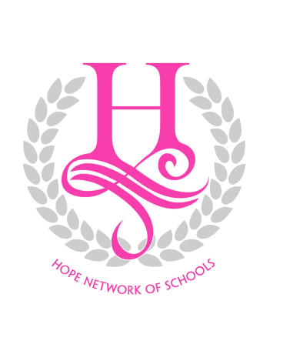
HOPE NETWORK OF SCHOOLS

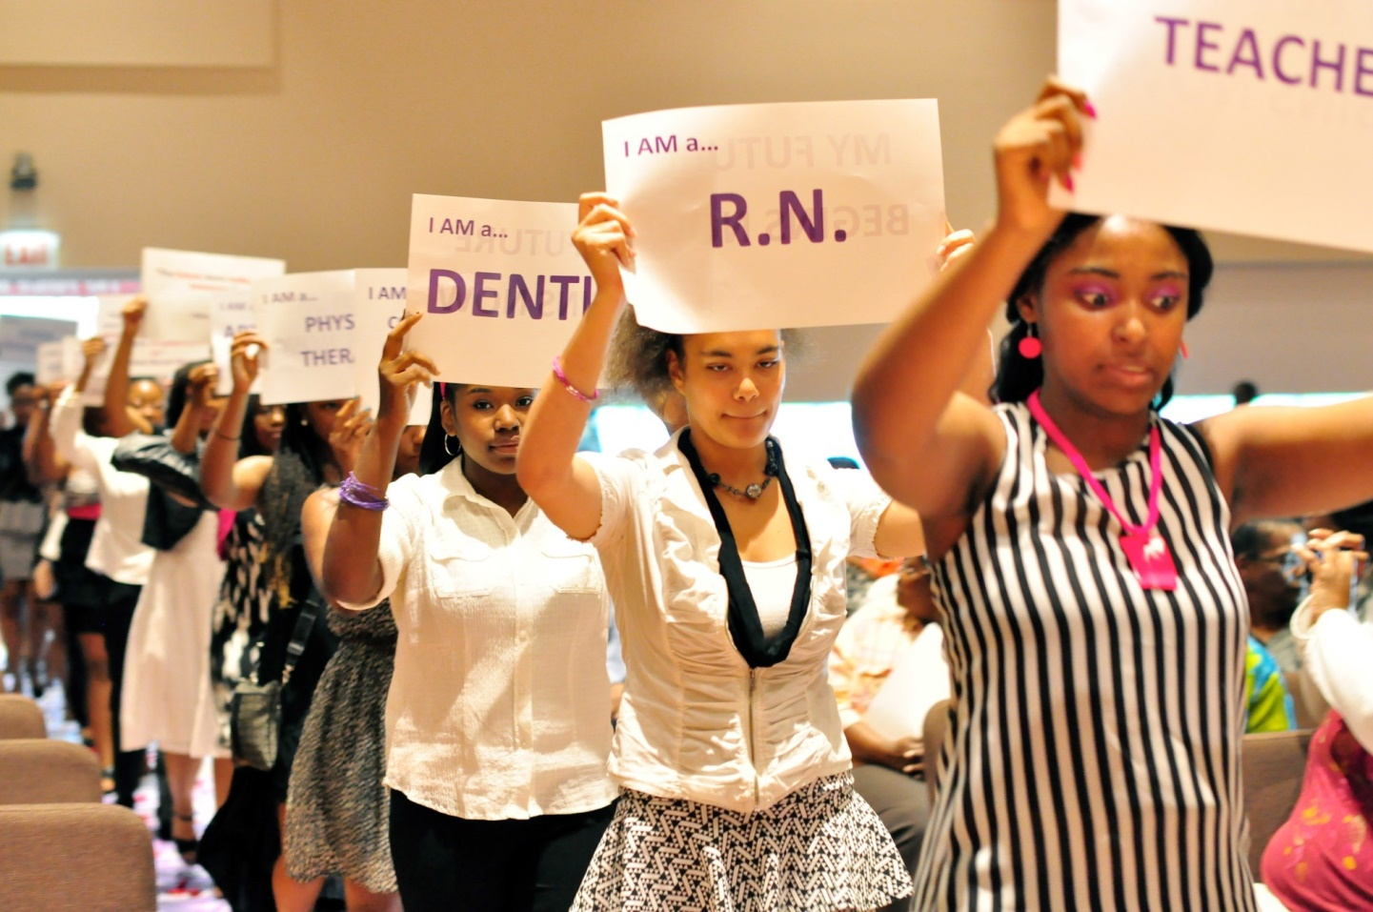

… transitioning girls into successful women!

The Katherine G. Johnson S.T.E.A.M. School for Girls
&
Community S.T.E.A.M. Center

EXECUTIVE SUMMARY

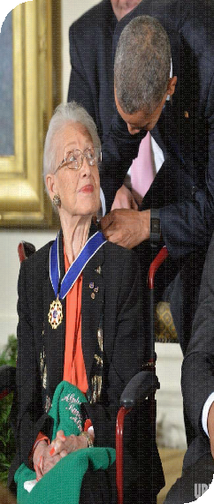
Name of Proposed School: H.O.PE. (Honor. Opportunity. Purpose. Endurance.) Network of Schools: Katherine G. Johnson S.T.E.A.M. (Science. Technology. Engineering. Arts. Mathematics.) School for Girls (HNS/KGJS).

Dr. Katherine Coleman Goble Johnson (born August 26, 1918) is an African- American physicist and mathematician who made contributions to the United States' aeronautics and space programs with the early application of digital electronic computers at NASA. Known for accuracy in computerized celestial navigation, she conducted technical work at NASA that spanned decades. During this time, she calculated the trajectories, launch windows, and emergency back-up return paths for many flights from Project Mercury, including the early NASA missions of John Glenn and Alan Shepard, and the 1969 Apollo 11 flight to the Moon, through the Space Shuttle program. Her calculations were critical to the success of these missions. Johnson also did calculations for plans for a mission to Mars. The life of Katherine G. Johnson was featured in the highly acclaimed movie, Hidden Figures. She was awarded the Medal of Freedom by President Barack Obama during a ceremony at the White House in Washington, D.C. November 24, 2015
Number and Type of Proposed School: (1) Contractual School
Mission: The Katherine G. Johnson Science, Technology, Engineering, Arts, and Mathematics (STEAM) School for Girls will provide a strong academic foundation which develops and empowers girls as global leaders, fully equipped to excel in the fields of Science, Technology, Engineering, Arts, and Mathematics in high school, college and beyond.
Vision: TThe Katherine G. Johnson S.T.E.A.M. School for Girls will be recognized as a global model for 21st century education and social emotional support which develops girls into master learners with analytical and critical thinking skills who positively impact the world as academic leaders,
S.T.E.A.M. professionals and agents of social change.

Educational Philosophy, Model & Culture: The educational philosophy of the Katherine G. Johnson
        - School for Girls (KGJSS) is guided by a student-centric learning model that is gender responsive and grounded in the socioecological theory. Through a student- centered, collaborative learning approach, students will receive a rigorous academic curriculum in an educational environment that is relational, holistic, strengths-based, trauma-informed and culturally competent. The social environment will be an extension of the classroom where students will

Katherine G. Johnson STEAM School for Girls 2018 RFP Submission

examine and define intersectionality, challenge social norms and reinforce protective factors. Students will learn fundamental academic skills that will support their successful transition through secondary and postsecondary education. HNS/KGJSS will provide a unique system of support which teaches students to be master learners and critical thinkers who are competitive nationally and in the global market.

HNS/KGJS will implement an inquiry-based and student-centered model that centralizes student learning and improvement. The model includes:
          - Instruction in the context of S.T.E.A.M. that is motivating, engaging, and aligned with applied knowledge of the real-world.
          - Use of S.T.E.A.M. methodlogies through inquiry and problem-based learning strategies which prepare students with 21st Century Learning skills
          - Teaching student integration and apply meaningful and important mathematics and science content through integrated learning acoss all disciplines.
          - Use of innovative evidence -based programs, design and instructional strategies which uses STEAM education fur developing decudtive and inductive reasoning.
          - A major focus on teamwork and communication which provide students freedom to think critically, creatively, and innovatively, as well as opportunities to fail and try again in safe environments. Collaborative learning groups will be used to increase team work ethics as well as the process of group dynamics.
- Use of art as a practical function. Students will learn to integrate and apply art (graphic design, animation, architecture, artistic design, drawing, graffiti, graphic, illuminated manuscript, illustration, mosaic, painting, performance, photography, sculpture, tapestry, and video) in S.T.E.M. based projects and design challenges to generate more creative and innovative thinking. Students will learn to apply art in real situations to increase applied knowledge which leads to deeper learning.
While test scores may serve as a primary metric for academic performance there is a direct correlation between school culture and student achievement. The model has been underdevelopment for over two years. The design team has conducted focus groups with over 100 elementary and high school girls, parents and educators to examine the norms, values and experiences that create a safe, nurturing yet rigorous academic environment for girls. As a result HNS/KGJS has established core five values which will be woven into the fabric of the school culture:

Exploration Instruction
  - HNS/KGJSS will provide students with experiences outside their communities to examine STEAM in the classroom of “Chicago” and around the world through integrated use of technology. Students in all grades will be challenged to ask questions in pursuit of answers in the academic and social environment.

Discovery Instruction
  - HNS/KGJSS will use discovery learning approaches designed to engage students in inquiry and problem-based learning that is guided by the teacher and discovered by the student. Through Socratic type questioning students will learn to use deductive and inductive reasoning to reach logical conclusions. The tenets of critical thinking will be integrated through age-appropriate activities which stimulate student thought and engagement.

Leadership

Sisterhood

Service

- HNS/KGJSS will challenge students to pursue and embrace leadership opportunities in school and the in the community. Character education will highlight specific attributes of leaders fundamental for each grade level.

- HNS/KGJSS will implement traditions, rites of passage ceremonies, celebrations and activities which promote and support positive peer and family relationships. HNS/KGJSS seeks to create a continuum of peer connectivity and school pride which extends beyond the K-8 experience into secondary and post-secondary education. Alumna will have opportunities to serve as Ambassadors (high school and college student mentors), youth advisory board members, receive academic scholarships as well as employment/internships.

- HNS/KGJSS will teach students the importance of service and civic engagement through age-appropriate service learning projects. Citizenship will be integrated into other subjects through a cross-curricular approach to discover “meaning” beyond the textbook. Students will be challenged to adopt servant leader principles as they develop into adolescence.

Demonstrated Capacity:

The proposed school will be the first educational institution governed by the Hope Network of Schools. However, the capacity necessary to successfully operate a contractual CPS school is demonstrated by the following:
  - Demoiselle 2 Femme, NFP
Demoiselle 2 Femme, NFP (D2F) has a strong history of providing community based programs to more than 7,000 girls on the far south side of Chicago and south suburbs for more than 23 years. D2F founded the HOPE Network of Schools and will provide social emotional services and support for the proposed school. D2F has successfully managed over 8 million dollars in public (county, state and federal) and private funding and operates two community-based sites in Englewood and Roseland. D2F has conducted rigorous evaluation of its programs and created an evidenced based curriculum which is currently being implemented in community based organizations across the country. D2F

staff have presented data relative to girls at national conferences and has representation on numerous community boards. To date, D2F has assisted over 800 young women to become first generation college graduates and awarded approximately $52,250 in academic scholarships. D2F currently implements seven programs: Femme 2 STEM, Demoiselle 2 Femme Signature Program, G-WAVE (Girls With A Voice Empowered), Money Smart Girls, the Leadership College, College Connection and T3-Transition, Transform, Transcend (education and workforce development for young women ages 18- 24). The success of D2F and its' Coalitions have been featured in the Chicago Tribune, Sun-Times, Chicago Defender, the STAR Newspaper, N’DIGO, ABC 7 News, ABC Heart and Soul , Fox News and Ebony Magazine.

Additionally, Demoiselle 2 Femme, NFP convenes the Chicago Coalition on Urban Girls (formerly the South Side Coalition on Urban Girls) and Partnership for a Better Roseland. The Chicago Coalition on Urban Girls is an alliance of over 30 organizations committed to improve the health, safety and wellness of girls living on the South Side of Chicago. Coalition activities include: hosting the “Girls on Fire” annual conference for more than 300 girls in partnership with Chicago Public High Schools, “Project 38” Teen Pregnancy Prevention and Awareness activities, International Day of the Girl Rally, Girl
KnoW More STI Education Campaign, and the “Girls in the City-South Side Edition” Resource Guide” which provides vital health and adolescent development information for girls as well as community resources. The guide will be distribute to over 5,000 girls in Fall 2017. Partnership for a Better Roseland (PBR) is a collaboration of nine organizations conducting Community Based Participatory Research (CBPR) with Northwestern University in Roseland. PBR is a grassroots response which capitalizes on the strength of CBPR to address the increasing youth violence perpetrated in and around community schools.

- Experience of Proposed School Executive Team & Board of Directors
The proposed executive team represents on average 15-35 years of public education experience in the areas of administration, finance, instruction, curriculum development, facility operations, school improvement, professional development, counseling, and social emotional support as well as nonprofit management, research, community organizing and engagement. In addition, the HOPE Network of Schools has recruited board members who have a passion for education and the development of girls in STEM education. The board is comprised of former educators and professionals in STEAM careers, parent advocacy, finance and community leaders. We have also developed an Education Advisory Committee which is comprised of retired Chicago Public Schools

administrators and educators to support the board in identifying additional resources and support as well as providing best practices, technical assistance and training.
The HNS/KGJS is committed to the academic and personal success of each student. Grounded in the Ecological Systems Theory1 (Bronfenbrenner,1979) the school will implement a socio- ecological approach to foster positive parent-child and peer relationships, as well as build connectedness to the community. Through the integration of community based partnerships, wrap around services and expanding resources the HNS/KGJS model is designed to reduce or eliminate risk factors by enhancing the protective spheres of influence that buffer youth against negative developmental trajectories. Specific activities which will drive success for the target population include:
Provide a safe, supportive school environment and passionate staff who encourage
  - students to excel. KGJSS wil implement a learning cultural that empower teachers to inform the field by developing best practices and collaborative research with universities.
  - Implement a rigorous academic curriculum which provides a strong foundation in STEAM and prepares students to compete locally and globally
  - Provide academic enrichment activities which increase student performance and confidence in their ability to pursue traditional and non-traditional careers in STEAM
  - Provide educational and cultural experiences which increase student exposure, positive points of reference and spheres of influence
  - Implement parent engagement strategies which increase parent-child relationships, student performance and support services for parents
  - Provide Gender-responsive services which are relational, holistic, culturally competent, strengths-based and trauma-informed
  - Implement a restorative discipline model which is strengths and asset based.
  - Group and individual mentorship opportunities for girls in grades 6th-8th
  - Provide support services and programming (through Demoiselle 2 Femme, NFP) to assist students in the successful completion of high school and college.

Targeted Communities & Recruitment Boundaries:

The primary site identified for the school is located at 1012 E. 47th Street in the Kenwood community. The school site is the former location of St. Ambrose Catholic School and is owned by the Arch Diocese of Chicago. The secondary site identified for the school is located at 4920 S. Dr. Martin Luther King Drive in the Washington Park/Grand Boulevard community.
1 Bronfenbrenner, U. (1979). The Ecology of Human Development: Experiments by Nature and Design. Cambridge, MA: Harvard University Press

The school site is the former location of Corpus Christi Catholic school and is also owned by the Arch Diocese of Chicago. Using an open enrollment process, the communities targeted for recruitment and enrollment include: Oakland, Bronzeville, Washington Park, Woodlawn, South Shore, Chatham, South Chicago, Englewood, Greater Grand Crossing, Auburn Gresham, Washington Heights and Roseland.
The rationale for opening the HNS/KGJS School in the proposed communities includes the following:
- High Percentage of students at surrounding schools not performing at state standards in math and reading
- High Percentage of school suspensions among girls of color in low performing K-8 schools.
- Increasing gaps for women and girls of color in science, technology, engineering, and mathematics (STEM) education and careers. While in a recent survey, three quarters of adolescent girls of color expressed interest in STEM.
- Increase percentage of girls enrolled in Kindergarten. Community data report 17.6% more boys in Kindergarten than girls in the target community
- Demoiselle 2 Femme, NFP existing community relationship, history of service and
and partnerships in ALL of the target areas.
- Increasing data which support same-sex education, specifically for African American and Latina girls.
- There are at least 3 same sex education high schools (LEO, Urban Prep, De La Salle Institute) for boys in the target communities. HNS/KGJS will leverage the success of these educational institutions to support the need for innovative same sex education for girls beginning at the K-8 level.

Parent & Community Support & Engagement
The HOPE Network of Schools will leverage its partnership with Demoiselle 2 Femme, NFP to implement and sustain a robust strategy for parent and community engagement. The HOPE Network of Schools (HNS) is a school network committed to cultivating academic excellence, leadership and success among students. HNS will create and implement innovative school models based on best practices, designed to make students lifelong learners and equipped with good citizenry and global skills. HNS was developed by a grassroots group of educators, nonprofit leaders, community members and S.T.E.A.M. professionals commissioned by Demoiselle 2 Femme, NFP to explore the needs, barriers and educational gaps required to increase the participation of girls of color in S.T.E.M. (Science.Technology.Engineering.Math). Over the past two years, a series of Think Tank sessions were held with STEAM professionals, educators, administrators, mental health professionals, community leaders, residents and parents to identify barriers and opportunities for a community based and designed STEAM school for girls.

Think Tank groups participated in four full day sessions which explored problems in the existing educational system, possible solutions and innovative school design strategies. Outcomes from the meetings were translated into graphic images highlighting aspects of a school model. Focus groups were conducted with over 100 current teachers from district operated and charter schools, parents, and girls (ages 8-16).

The integration of the socio ecological model into the school design creates an interconnectedness between parents and community that is a lifeline of support and sustainability of the school. The HNS/KGJS will serve as a hub for community activities, events, resources and engagement that strengthens families which are the heartbeat of communities. As a partner, Demoiselle 2 Femme, NFP brings over 60 active partnerships with schools, community and faith based organizations, universities, corporations and civic leaders. D2F has representation in over 15 community advisory councils which will increase opportunities for recruitment, community awareness, and access to resources. Parents will receive services through the Parent School for Success and Parents Supporting Parents initiatives and the community will be informed of open activities at HNS/KGJS through community newsletters and meetings which will be hosted at the school. Presently, The HOPE Network of Schools has enlisted more than 50 retired CPS teachers and specialists to support the school as volunteer teacher and student mentors, tutors and community engagement specialists. The staff at D2F have extensive experience in community engagement and will serve as an asset in the creation and execution of strong parent and community activities.

