2.2.2: Curriculum
Describe the school’s curriculum for each subject area and instructional level, along with rationale for the curriculum development or selection decisions. Applicants must address the following: • Describe the curricula for your proposed school in the core subjects of reading/ELA, math, science, and social studies.
Explain the rationale for your curricular choices, such as textbook selection and supporting materials by subject. Provide evidence that any Note: Any applicant proposing a Next Generation/Blended Learning Design Model must complete all additional questions found in Appendix 1 to this RFP. 2017 Request for Proposals – Operators New to Chicago Page 13 selected curricula are research-based, standards-aligned, have been effective with students similar to those the school expects to serve, and will keep students on track for college and career readiness.
• Identify the full sequence of subjects/courses that students will be required to complete and the exit standards necessary to graduate from your school. Include any optional subjects/courses.
• Provide a detailed timeline for the selection and development of additional curricula (in any areas where it is not already fully developed). If the school will develop the curriculum, detail the responsible staff, the development process, key milestones, and the status of the development process.
• Explain how teachers will know what to teach and when to teach it, including the curriculum resources that will support instructional planning. Identify who will be responsible for creating or selecting these resources.
A curriculum defines what students should know in terms of content and be able to do skills. Based on our research, the most rigorous curricula is created by excellent teachers that pull together materials from various sources based on what students should know and be able to do at the end of the course in combination with a data-informed understanding of students baseline knowledge and skills. Thus, Evelyn Ann Charter Institute teachers will create learning materials for our students. Further, the master teachers and the curriculum coordinator will design curricula to be used by newer teachers in the following years. In addition, because all materials will be stored on-line, sharing of materials will be automatic.
The curriculum, instruction, and assessment(modeled after Intrinsic) at Evelyn Ann Charter Institute will be meticulously aligned to the Illinois Learning Standards, Common Core State Standards for English Language Arts & Mathematics, Next Generation Science Standards, and the College Readiness Standards. Thus, college-level courses will follow their respective course syllabi, in which students will receive college credit upon successfully meeting all course requirements. The proposed scope and sequence, which outlines the order in which content and skills will be delivered, has been intentionally designed to integrate and reinforce concepts across disciplines and grade levels (see Scope and Sequence Attachment). Through technology-enabled data collection, our master teachers will routinely assess the effectiveness of the curricula.
According to Richard Elmore, the way to improve student learning at scale is to simultaneously improve the three domains within the Instructional Core – the interdependent relationship between the student, the teacher, and the content. The EACI teaching team will possess both the experience and expertise in delivering a rigorous curriculum through proven and effective instructional strategies. They will create rich learning experiences that will help all students achieve high levels of academic success. We will leverage technology to increase rigor, tailor instruction, and engage students with meaningful learning activities. Elmore also maintains that “task predicts performance.” Thus, we will ensure that all students will have the opportunity to grapple with challenging tasks to improve their critical thinking and problem-solving skills.
In creating, and designing performance tasks, our master teachers will examine the depth of technology integration on spectrum from substitution to redefinition. Ruben R. Puentedura has done extensive research on the role of technology on pedagogical content knowledge (TPCK) and the use of technology in creating student tasks (The SAMR Model – see graphic below). We have seen where technology has been used to strengthen foundational skills, but we believe technology has the potential to extend and deepen learning in ways that have yet to be fully explored. When developing tasks, our teachers will work to both enhance and transform the learning experience for our students.

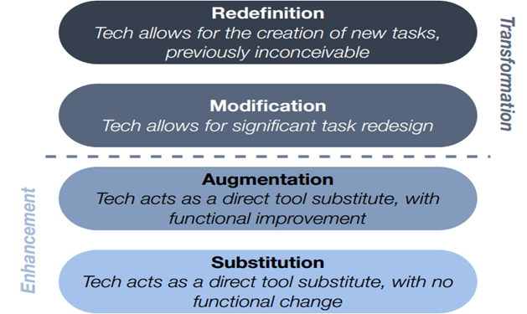

The Universal Design for Learning (UDL) will guide the design of the curriculum, instruction, and assessment at Evelyn Ann Charter Institute Schools. Student data and engagement with the content will inform adjustments to future learning experiences. UDL allows teachers to create a flexible learning environment in which students become more active over their learning and progress. Through technology, students will be able to track their own progress. They will become more aware of their metacognitive processes and become co-designers in personalized learning paths. The diagram below shows how personalized learning in the context for the Common Core Era can help students become more autonomous learners, which we believe is critical for college and career success.
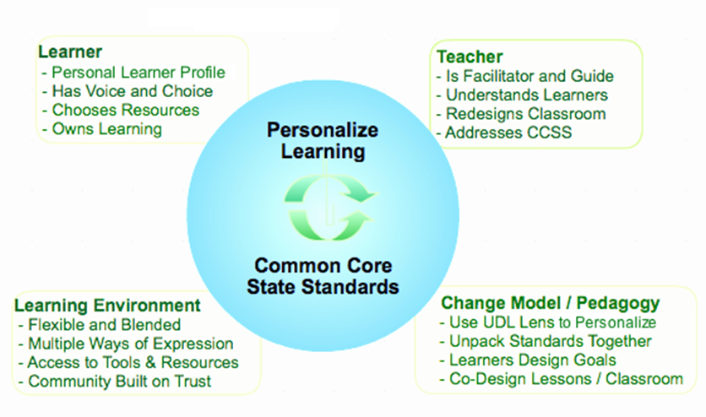

As shown in our Assessment Plan, Evelyn Ann Charter Institute will rigorously measure academic growth, academic attainment, participation and student learning styles. The new use of the SAT defines college and career readiness is when their SAT section scores meet both the Math and the Evidence-Based Reading and Writing benchmarks. It is important to note that college readiness is a continuum — students scoring below the SAT benchmarks can still be successful in college, especially with additional preparation and perseverance. For instance:
Students with an SAT Math section score that meets or exceeds the benchmark have a 75 percent chance of earning at least a C in first-semester, credit-bearing college courses in algebra, statistics, pre-calculus, or calculus.
Students with an SAT Evidence-Based Reading and Writing (ERW) section score that meets or exceeds the benchmark have a 75 percent chance of earning at least a C in first-semester, credit-bearing college courses in history, literature, social sciences, or writing classes.
Grade-Level Benchmarks Defined
- Students who take the PSAT/NMSQT, PSAT 10, and PSAT 8/9 see grade-level benchmarks on their score reports. Grade-level benchmarks indicate whether students are on track for college and career readiness. They are based on expected student growth toward SAT benchmarks at each grade. Preliminary benchmarks were used for the 2015 PSAT/NMSQT and fall PSAT 8/9 scores. Green: The section score meets or exceeds the benchmark.
- Yellow: The section score is within one year’s academic growth of the benchmark.
- Red: The section score is below the benchmark by more than one year’s academic growth.
Benchmark Values and Section Score Ranges
SAT College and Career Readiness Benchmarks
- Evidence-Based Reading and Writing: 480
- Math: 530
11th Grade Benchmarks
- Evidence-Based Reading and Writing: 460
- Math: 510
- 11th Grade Section Score Ranges
160–760 Point Scale
 | Red | Yellow | Green
Evidence-Based  Reading and Writing | 160–420 | 430–450 | 460–760
Math | 160–470 | 480–500 | 510–760

10th Grade Benchmarks
- Evidence-Based Reading and Writing: 430
- Math: 480
9th Grade Benchmarks

- Evidence-Based Reading and Writing: 410
- Math: 450

- 9th Grade Section Score Ranges
120–720 Point Scale
 | Red | Yellow | Green
Evidence-Based  Reading and Writing | 120–380 | 390–400 | 410–720
Math | 120–420 | 430–440 | 450–720

Whereas, ACT defines college readiness as, “the level of preparation a student needs to be ready to enroll and succeed without remediation in an entry-level, credit bearing course (in each content area) at a two-year or four-year institution, trade school, or technical school.” Multiple data sources will inform all curriculum-planning at Evelyn Ann Charter Institute Schools. The curricula will be aligned tightly with assessment measures to adjust learning plans for students as needed to ensure college and career readiness and success.

"Improving The Instructional Core." http://www.acsa.org/MainMenuCategories/ProfessionalLearning/ Leadership Coaching/Coach-Resources/Imp-Instr-Core.aspx
Ruben R. Puentedura, Ph.D. "A Toolkit for Decision Making and Design: TPCK + SAMR." http://hippasus.com/resources/educause2008/Puentedura_TPCKplusSAMR_Print.pdf
Barbara Bray and Kathleen McClaskey. "UDL Guides Personalizing Learning to Meet the Common Core." http://barbarabray.net/2012/06/04/udl-guides-personalizing-learning-to-meet-the-common-core/
"College Degree Completion Rates by Race/Ethnicity and College Readiness." http://www.act.org/research/

