2013 New Schools Request for Proposals (RFP)
Tier 2 Questions

Directions: Responses to Tier 2 questions should be submitted in a new document that is separate from the Tier 1 proposal narrative. The Tier 2 responses should only include information that directly responds to the questions below; applicants should not submit any additional materials or updates to any other section of the RFP.

Please submit Tier 2 responses directly into your unique Dropbox folder titled “2013 [proposal name] Tier 2” by end of business, Tuesday, December 3, 2013.

- Please provide updates to any of the following sections of the Tier 1 RFP, if your Design Team’s plans have evolved in the time span between Tier 1 submission on September 30th and Tier 2 submission. Please note that the same Tier 1 evaluation criteria will be applied to the review of the corresponding questions in the Tier 2 proposals.

  - Section 1.1. Parent and Community Engagement/Need in Targeted Community (p. 24)
    - 1.1.a. Parent and Community Engagement (Preparation of Proposal)
    - 1.1.b. Description of Need in Targeted Community

Horizon Science Academy-Chatham has been proposed by Concept Schools to lease space within a multi-purpose facility known as The Legacy Project, spearheaded by Rev. Charles Jenkins of Fellowship Missionary Baptist Church. The Church’s vision is to develop a multi-faceted community-focused project that serves the greater Chatham neighborhood includes access to health care, quality education and spiritual wellness. Concept Schools is excited to partner with The Legacy Project because our shared vision and goal of working within underserved communities. The Legacy Project will be located at 8522 S. Lafayette in the Chatham neighborhood, which includes Chatham, West Chatham, East Chatham and a northern portion of West Chesterfield

Chatham’s history runs deep among African-American Chicagoans, and to that end, we recognized the importance of a two-way dialogue with neighbors, parents and community leaders. Chatham has the distinction of being one of the only neighborhoods in Chicago that successfully transitioned from a European American middle-class community into a community of middle-class African Americans, who were drawn to the area specifically for its strict property standards, high levels of community organization and good neighborhood schools.

Starting in the late 1990s, however, the community underwent another transformation as reports of crime, property neglect and economic instability became more frequent. Since then, community leaders, neighborhood associations and residents have devoted their energies to a number of revitalization projects designed to assure that Chatham would remain viable and desirable to new families. That is why we are so excited about the possibility of being part of the revitalization.

Community input for the project has been critical, and we are so grateful to have met and talked with the many neighbors, community members and parents. Our outreach took a two-pronged approach: we aimed to inform the community about our proposal, but we also had a goal of gathering feedback that would help shape the final proposal. We engaged Chatham using a multi-layered approach, which is outlined in the diagram below:
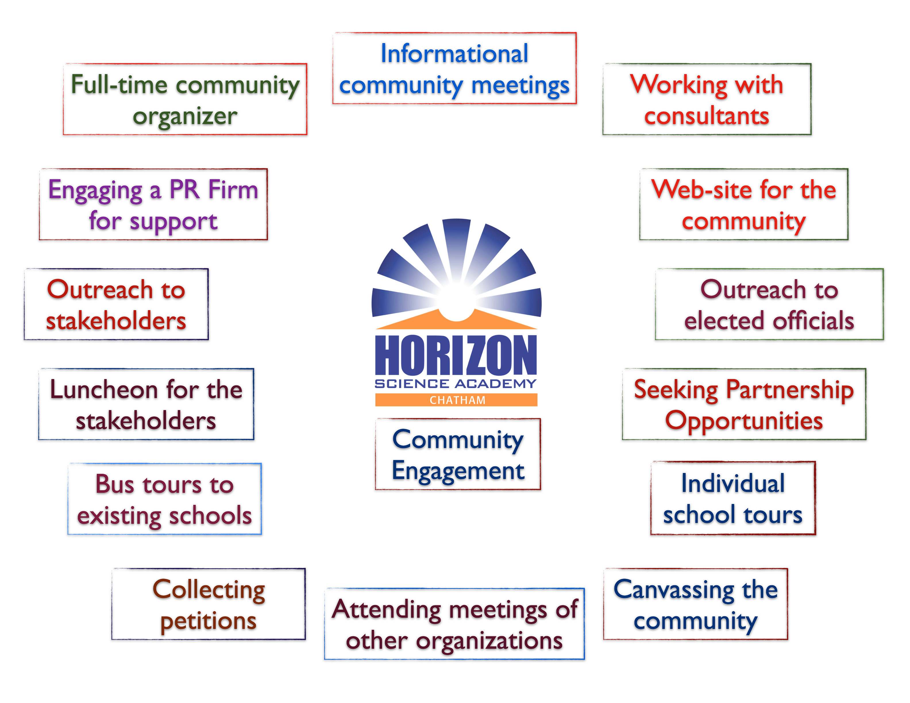
We hired a full-time community organizer, Velena Miller, to help us engage the community. Velena has began working for Concept in the beginning of October and will continue doing so until the end of January 20014. She is familiar with the larger Chatham community as she has been involved in community organizing there in the past. Velena has been a great addition to our team as she spends her days in the community meeting with individual community members, facilitating the canvassing efforts and handling all the logistics for the informational meetings and other strategies that we have implemented. Please find Velena’s resume in Appendix 1-Community Organizer Velena Miller Resume.

In addition to a full-time community organizer, we also worked with a prominent leader in the African American community, Hermene Hartman, as a consultant. Hermene Hartman is one of the most significant and influential Black women in American publishing. She serves as President and CEO of the Chicago-based Hartman Publishing Group, Inc. Her weekly column, Publisher’s Page, provides social commentary on hot topics of the day. Her radio program, VIEWS OF THE HEART, appears on Clear Channel station, WVAZ daily at 9:15 and 2:15.
N'DIGO, was founded in 1989, has the largest African American newspaper circulation in the nation and the largest alternative newspaper circulation in Chicago. N’DIGO is a weekly lifestyle publication for progressive readers. In 1995, N'DIGO PROFILES was established as a special annual publication, with a targeted insert in the Chicago Tribune and Crain's Chicago Business Magazine.
Ms. Hartman is founder and president of N'DIGO Foundation, a 501c3 not-for-profit organization, which began in 1995. It sponsors an annual Black Tie Gala, for the sole purpose of raising funds for educational pursuits. From 2004 – 2007 Ms. Hartman served as president of the Alliance of Business Leaders and Entrepreneurs (ABLE), a business group, dedicated to entrepreneurial pursuits, with 70 members with collective revenues of nearly one billion dollars. She is the only woman to have served as President of the organization and the only President to serve two terms. Ms. Hartman received an M.B.A. from the University of Illinois, a M.A. degree in sociology an MPH with Honors from Roosevelt University and a B.F.A. from Roosevelt University. She has received more than 200 awards for outstanding achievement in media, business, community services, education, and communication. Prior to a publishing career, Hartman was Vice Chancellor of External Affairs at City Colleges of Chicago and a Social Science Professor.

As indicated in the diagram above, we have organized community meetings at various locations in Chatham. Below are the notes from those meetings:

Whitney M. Young, Jr. Library – November 7, 2013
- 16 attendees
- Concept Schools HSA-Chatham presentation done by Salim Ucan & Regina Armour
  - Velena Miller – Community Organizer for Chatham present
  - Gabriela Amante – Community Organizer for Chicago Lawn present
- Questions/Comments
  - What exactly is the difference between a charter and a public school?
  - Will the new school be selective enrollment?
  - Will there be a testing process to enroll?
  - How long has CMSA been here in Chicago?
  - We need more of our kids in activities like robotics.

Fleck’s Coffee – November 11, 2013
- 12 attendees
- Concept Schools HSA-Chatham presentation done by Salim Ucan & Regina Armour
  - Velena Miller – Community Organizer for Chatham present
- Questions/Comments
  - Are the teachers non-union in your school?
  - I am a member of Fellowship Baptist Church and I never heard of a school being involved in the Legacy Project.
  - When will the application process begin and how can I enroll my grandson?

Whitney M. Young Library* – November 19, 2013
- 18 attendees
- Concept Schools HSA-Chatham presentation done by Salim Ucan & Regina Armour
  - Velena Miller – Community Organizer for Chatham present
  - Mrs. Patricia Taylor – parent of three sons who attend HSA-McKinley Park but live in Chatham present to speak to other parents
- Questions/Comments
  - Will there be any union teachers working at HSA-Chatham?
  - What is a charter school?
  - When will information be released about applying and enrolling?
  - Chatham has a large senior population. Where will the children come from that will attend?
  - Will Chatham families have first priority?

Mather’s Lifeways Cafe – November 23, 2013
- 5 attendees
- Concept Schools HSA-Chatham presentation done by Salim Ucan & Regina Armour
  - Velena Miller – Community Organizer for Chatham present
- Questions/Comments
  - Are most of your teachers and administrators Turkish?
  - Why are most of the teachers and administrators in your schools Turkish?
  - Will we seek out teachers from the community to employ?
  - Why do people from Turkey want to open schools here in the Midwest?
  - I am a member of the Chatham Architectural Foundation and would love to partner with HSA-Chatham and involve kids in our walking and bus tours of the community. It’s another way for them to learn about their community.
*Community meeting was moved from St. Mark’s Church to the Whitney M. Young, Jr. Library because the 83rd Street/St. Lawrence Block Club meeting was cancelled.

West Chesterfield Community Cultural Center-
- Eight community associations in attendance – representing their communities and introductions of presidents and vice presidents
  - Deborah Foster-Bonner – Reunite Chatham
  - Roosevelt Vonil – Greater Chatham Alliance
  - Roseland Heights Community Association – Clevon Tucker
  - Chesterfield Community Council – Dennis Hanks
  - Rosemoor Community Association – Gloria Corgy
  - West Chesterfield Community Association – Michael LaFargue & Sharon Banks-Pincham
  - Renata Gilbert-Kyles – Block president of 9 block clubs, Asset Mgr. for West Chesterfield
- Other Organizations represented:
  - Father’s, Families and Healthy Communities – Sequane Lawrence (mentors men in fatherhood skills)
  - Clean & Green Community – Mr. Alonzo (works with young people cleaning up the community and painting curbs, hydrants, signs etc.)
- Three elected officials in attendance:
  - Alderman Roderick Sawyer
  - Alderman Howard Brookins, Jr.
  - Cook County Commissioner Stanley Moore (4th Ward)
- Legacy Project was presented by Jonathan Wilkes and LaVon Johns (attorney for FMBC) – Concept Schools presentation done by Regina Armour

- Questions/Comments
  - “Have there been any traffic impact studies done on how the Legacy Project will affect quality of life and safety in the neighborhood?”
  - “This deal seems already done! Why weren’t we informed at the beginning in the planning stages?”
  - “We need a quality choice in the community! Gillespie is a level II school and Harlan High School has been on probation for 14 years! That’s ridiculous!”
  - “I want to be able to step out of my door and send my children to a quality school.”

Commonwealth Community Baptist Church – 140 West 81st Street
- Video and power-point presentation on The Legacy Project was compelling well received
- Articulation of the difference between FMBC and FEED
- Articulation of the Donation Blessing from Hobby Lobby family
  - Largest gift outside a HBCU donation
  - 230,000 sq ft over 14.5 acres
  - Mixed development site
- Site is an historical site – hence, The Legacy Project (rationale for name)
  - Vacant 10 years
  - Reduces property values as is
  - “We’re not coming to take away, but to contribute!”
  - “We’re here to minister to the whole family”
- Will provide:
  - 400 jobs
  - School will provide for 730 students
  - 200 people to be seen in health care center daily
  - 3000 seat community auditorium

Questions from audience:
- What does “non-selective enrollment” really mean?
- Will you phase in more grades over time?
- Will there be community partnerships? Jobs?
- Will Chatham get short-changed again?
- Are there any minority contractors?
- Make sure our seniors are not forgotten! (Michelle McGee – President of 8 Block Clubs)
- “How can we make the Legacy Project accountable for what you are promising?”

Notes from Concept Schools Luncheon
November 21, 2013
N’Digo Foundation - Chicago, Illinois
A luncheon was co-planned and hosted by Ms. Hermene Hartman the executive director of the N’Digo Foundation and featured in the Who’s Who Among Chicago African-Americans. Ms. Hartman along with the Concept Schools team brought together major community builders and stakeholders from the Chatham neighborhood. The list of guests include:
Howard Brookins, Jr. – Alderman, 21st Ward Howard Brookins, Sr. – Fmr. Alderman, 21st Ward
Elgie Sims – State Representative 34th Dist. Roland Burris – Fmr. Illinois State Comptroller
Rev. Patric D. Brown – St. Mark’s AME Church Joyce Washington – Advocate Hospital
Deborah Brown – Community Affairs – NBC Rev. Jeanette Wilson – Rainbow PUSH
Sister Claudette Muhammad – Nation of Islam Dr. Leroy Jones – Chicago State University
Prince Asiel – Owner, Soul Vegetarian East George Ward – Seaway Bank
Betty Clawson – Clawson Beauty School Josephine Wade – Hard Times Restaurant
Jonathan Wilkins – Fellowship Baptist Church LaVonn Johns – Attorney for the Legacy Project
Bruce Montgomery – Small Business Network Students of the CMSA Robotics Team & Coach

Noteworthy Points:
- The purpose of this luncheon was to being together major community members and stakeholders in the Chatham area to inform and educate them about the Legacy Project overall, but specifically the proposed Horizon Science Academy – Chatham school.

- Luncheon guests were introduced to several students of the current Chicago Math & Science Academy (CMSA) Robotics Team and their teacher-coach. These students and their teacher-coach sat with the guests during lunch and had conversations about their experiences at CMSA and the robotics program.

- Rev. Jonathan Wilkins and Ms. LaVon Johns along with the Concept Schools team presented he Legacy Project as a multi-purpose use facility with Concept Schools as the vetted and chosen school that was the best fit for the Chatham community.

- Students of the Robotics Team from CMSA provided a brief robotics demonstration using the current models they have recently built. They also provided a forum for luncheon guests to ask questions.

- During the wrap-up of the luncheon, the Concept Schools team fielded questions about the school and accepted support letter and other forms of partnership and assistance toward to opening of the school in August 2014

Questions/Comments
  - Does Concept Schools have the capacity to complete the build-out of the property so that school opens by August 2014
  - Will there be a priority policy for Chatham neighborhood children?
  - Has there been a traffic impact study done on the quality of life and safety concerns once the school is open?
  - This project will transform the Chatham community and increase our property values that have been slipping for years.
  - The school name should not be Chatham, but it should either reflect the legacy of George Johnson (previous owner of Johnson Products) or Rev. Clay Evans, brainchild of the Legacy Project.

Below are additional notes from the meetings with stakeholders, parents, community members, and leaders in the Chatham community:
Topic | Highlights
Contact Calls, outreach to stakeholders and meetings | Block Club Presidents 83rd and St. Lawrence; 78th and King Drive  - St. Mark Church- scheduled Community meeting- Susan Obasa-Illidge  - Outreach to Stakeholders – Virginia Fullman former president of 83rd Street Cooperative
Community Outreach Presentations  - Fleck’s Restaurant 11- 11  - 2 Presentations at Whitney Young Library11-7 & 19  - Chesterfield Community Council Meeting (Tuley Park)11-20  - Mather’s Café 11-23 | - Overview about Concepts School and how it will help revitalize and enhance the community, as well as how a STEM focused school will help their children be more competitive globally by increasing their standard of education, why this particular location and being well-rounded  - Video Presentation of the Fellowship Legacy Project and the Concept School Philosophy of a higher standard of learning and cultural diversity  - Concepts banners and posters strategically located for exposure  - Table set up with materials, i.e. petitions, attendance sheets, information sheets etc...  - Questions and Answers  - Asking for support and petitions signed  - Served light refreshments  - Reflections  - Next Event
Community Meeting: Chatham Business Association, SBDI – monthly membership meeting 11-12 | - Attended meeting to learn more about the business community and to network.  - Shared Concept catalog with President of CBA, Melinda Kelly and others.  - Results of the meeting:  - Met a Stakeholder –Jack Stonebraker, Consultant who offered his assistance because of his impression of Concepts.  - Follow-up with him  - Scheduled a meeting with Mr. Ucan; discussed what we needed him to help us with CBA  - Business letter of support from him, as well as potential partnership  - Liaison between Concept and CBA-President Melinda Kelly  - Liaison between some other stakeholders  - A partnership meeting with Mr. Ucan and President of Lumity – Kara Kennedy
Community Meeting: Chesterfield Community Council 11-20  Contact Person: Eli Washington – President  Invited Ronald Bellamy – retired CPS School Administrator and Commander Thompson of the Harold Washington American Legion to join them for a formal presentation. (previously met with both parties one-on-one)  Results: Letters of support from both of them  Invited members of the Chatham Avalon Park Community Council | Special Presentation  - Overview about Concepts School and how it will help revitalize and enhance the community, as well as how a STEM focused school will help their children be more competitive globally by increasing their standard of education, why this particular location and being well-rounded  - Video Presentation of the Fellowship Legacy Project and the Concept School Philosophy of a higher standard of learning and cultural diversity.  - Concepts banners and posters strategically located for exposure  - Table set up with materials, i.e. petitions, attendance sheets, information sheets etc...  - Questions and Answers  - Asking for support and petitions signed  - Served light refreshments
Bus Tour to HSA McKinley Park Concept School  November 12th and 26th.  This tour was done in conjunction with the Perkins’s Team who invited the parents. | Parents and Stakeholders were invited on both tours.  - Overview Concept and what is expected of them  - Met the Administrator, Faculty and Students  - Tour the building and witnessed some classroom demonstrations.  - Questions and Answers  Results  - Followed up with parents and had a set down interview with parents  - Letters of support from parents, grandparents and guardians.  - Letters of support from stakeholders  - Re-visited parents to get signatures for the letters.  - Interviewed parents from November 26th bus tour on November 30th, secured letters of supports from them
Community Meeting: Greater Chatham Alliance November 16th | - Attended meeting to learn more about the Greater Chatham Alliance and to network.  - Kept a low profile because the past Principals of CPS were on the Agenda  - Interviewed with President of Greater Chatham Alliance
Individual Stakeholders Meetings | - Jessie Wilson (Security for CMSA) helping us meet Police and Fire Chief Commanders.  - Met with Jack Stonebraker – resulted in two partnership letters  - Met with James Shotwell – introduction to Eli Washington of the Chesterfield Community Council; resulted in a special meeting on November 20th ; Senator Donne Trotter – opposes Charter Schools  - Shirley Macklin – Prairie Street Block Club intro to Roosevelt Vonil – Greater Chatham Alliance  - Whilmetta Harrell 78th MLK Block Club  - Mr. Perkins introduction to Commander Thompson – letter of support, Commander Thompson introduces Ronald Bellamy –Former CPS Administrator – results letter of support and interest in serving on the school committee  - Maryellen Drake- Introduction to Chatham Avalon Association and Gale Hunter– support pending  - Calvin Bridges –Chicago Praise Ministries –Letter of support  - Ernest Griffin-Chatham Food Market –letter of support

We also organized two bust tours from each community (Chatham and Chicago Lawn) to one of our existing schools in Chicago. Parents from both communities had a chance to visit Horizon Science Academy-McKinley Park, take a tour of the school, meet with students, parents, and teachers and ask questions about the school and the program.

In addition to the websites that we designed for the communities, we printed outreach materials that have been used in meetings, canvassing, and other outreach activities. They are translated into Spanish in for the Chicago Lawn community dues to the significant Latino population in the Chicago Lawn Community. Some of these outreach materials are include in Appendix 2-Concept-Outreach_Materials.

Many of the questions and concerns we heard were not unique to Chatham – questions about charter schools, and concerns about student safety and safe passage, teacher recruitment, and curriculum are issues any parent would want addressed. What has particularly valuable about this dialogue, however, is that it has truly helped to shape our proposal into a better and more inclusive one. Thanks to this input, our project has changed – and for the better. Below is a sampling of new or changed components of our plan that are a direct result from community engagemen:

- A commitment to work with CPS to identify a “prioritization” enrollment system (not selective) to ensure that families and students in the neighborhood have access to the school.
- Plans to honor the strong and proud African-American history of Chicago by re-naming the project in Fellowship’s name and/or the Johnson Family. Possibilities include: Horizon Science Academy- Clay Evans, Horizon Science Academy-Johnson-Evans, and others.
- Developing partnerships with the local library branch and local businesses. Possibilities that we have discussed with parents and business owners include internship programs, mentorship programs and job shadow days.
- Targeting recruitment to West Chesterfield after community representatives expressed concern about being excluded from future enrollment outreach efforts.
- Guaranteeing a safe, nurturing and supportive climate within the school by adhering to character-driven hiring and professional development practices.
- Guaranteeing “safe passage” to all of the students and families connected to the school by exploring transportation options after parents expressed concern about navigating busy traffic routes.

The other comments we have experienced are:
- Residents want to walk out of their homes and send their children to a quality school.
- Robotics is something all children should have access to.
- STEM is the future.
- This is an exciting, transformational project for Chatham.
- Real estate values will increase with a good school.
- If schools such as this were accessible, many more would graduated (in the past)

Horizon Science Academy-South Chicago is proposed for the Chicago Lawn area—a Chicago Public School Board (CPS) priority area. The Chicago Lawn area - or “Marquette Park” - is known as Community Area 66 out of the 77 community areas in Chicago and is approximately 8 miles SW of the Loop. Chicago Lawn is home to tightly knit communities around neighborhood churches and schools, though it has also endured difficult times. As a result of Chicago's abrupt change in racial demographics in earlier decades and into the 1960s, Chicago Lawn became the center for civil rights groups' open housing marches, and was one of the most tumultuous areas in the city.

Today, Chicago Lawn stands as one of the most diverse neighborhoods. In addition the African-American community that moved in during the 1990s, Latinos make up a significant amount of the population, as well as Middle Eastern. Though rich in diversity, Chicago Lawn has not been immune to the recent decline of the economy’s industrial sector. As a result, schools are overcrowded, jobs are scarce and access to healthcare is limited. Chicago Lawn, as identified by CPS, is in desperate need for quality school options. We also recognized that as a result of those tight-knit multi-generational communities, our team was compelled to be as inclusive as possible and not just to families with school-age children.

We are grateful to have met and talked with the many neighbors, community members and parents. Our outreach took a two-pronged approach: we aimed to inform the community about our proposal, but we also had a goal of gathering feedback that would help shape the final proposal. Similar to Chatham we engaged Chicago Lawn using a multi-layered approach through our community meetings, door-to-door outreach and one-on-one conversations. These strategies are outlined in the diagram below:

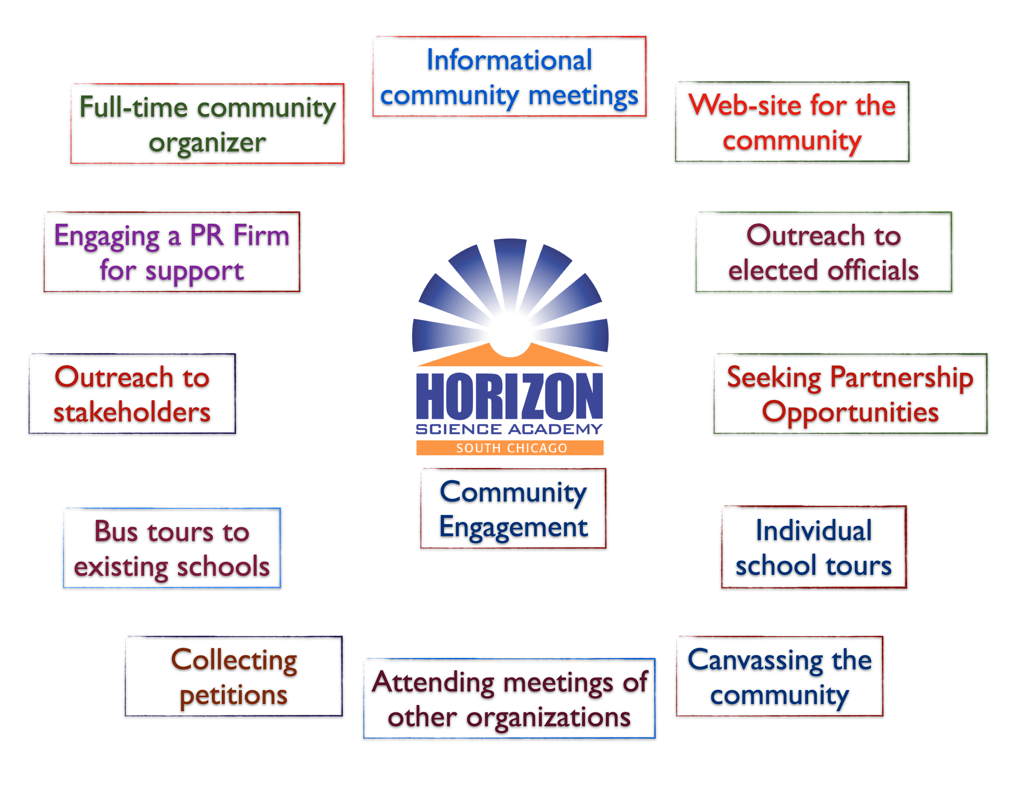
We have had 3 community meetings, knocked upon countless doors and had over 2,000 conversations. Many of the questions and concerns we heard were not unique to Chicago Lawn – questions about charter schools, and concerns about overcrowding and student safety and safe passage, teacher recruitment, and curriculum are issues any parent would want addressed. We also heard very clearly that families are frustrated that they have to travel outside of the community to enroll their child into a college-prep school.
In addition to connecting with families, we have also had the opportunity to explore partnership that will add value to the proposed school – establishing it not only as an academic center, but also a community center:
- We are currently exploring a partner to develop a youth center in the community. This project has been spearheaded by Ald. Joann Thompson and after several conversations with her and her staff; we are excited about the possibility of being part of a larger community-focused development.
- In our enrollment outreach efforts, we will make a special effort to educate parents on the special needs resources available at Horizon Science Academy.
- A commitment to continued dialogue with residents as we move through the process, since some families expressed a frustration with broken promises or lack of follow-through on previous community projects.

We hired another full-time community organizer, Gabriela Amante, to help us engage the Chicago Lawn community. Gabriela has began working for Concept in the beginning of October and will continue doing so until the end of January 20014. She is familiar with the larger Chatham community as she lives in Chicago Lawn and has been involved in community organizing there in the past. Gabriela spends her days in the Chicago Lawn community meeting with individual community members, facilitating the canvassing efforts and handling all the logistics for the informational meetings and other strategies that we have implemented. Please find Gabriela’s resume in Appendix3-Community Organizer Gabriela Amante Resume.

Below are the summaries of the meetings that we have held and notes from such meetings in Chicago Lawn:

Topic | Highlights
Outreach to stakeholders and meetings | - Outreach to Stakeholders – Maggie Perales, Southwest Organizing Project  - Latino Organization of the Southwest – Hector Rico  - Greater Southwest Development Corporation- Nick Kollias  - Commissioner Special Service 59- Jose Alejandro Garcia
Weekly meetings with Executive Team and Outreach Team | - Weekly meetings with team to discuss what has been done, what needs to be done, what works and what did not work.  - Strategies and plan of actions  - Communication is the key and staying in constant contact with each other, as well as sharing new information.  - Providing support for both Chatham and Chicago Lawn, as needed.  - Working closely with the canvassers, make routine visits to various locations where they were canvassing and getting petition signed by parents and supporters.  - Table set up at Rio Valley – 63rd street November 9, 10 and 16th and 17th  - Canvassed various locations including laundromats, supermarkets and Super Mall.
Community Outreach Presentations  - Chicago Lawn Library 11-12  - 8TH District Police Department 11-14  - Latino Organization of the Southwest | Set up was the same:  - Overview about Concepts School and how it will help revitalize and enhance the community, as well as how a STEM focused school will help their children be more competitive globally by increasing their standard of education, why this particular location and being well-rounded  - Translator from English to Spanish (Gabriela Amante)  - Concepts banners and posters strategically located for exposure  - Table set up with materials, i.e. petitions, attendance sheets, information sheets etc...  - Questions and Answers  - Asking for support and petitions signed  - Served light refreshments  - Reflections  - Next Event
Bus Tour to HSA McKinley Park Concept School  November 12th and 26th. | Parents and Stakeholders were invited on both tours.  - Overview Concept and what is expected of them  - Met the Administrator, Faculty and Students  - Tour the building and witnessed some classroom demonstrations.  - Questions and Answers  - Results  - Followed up with parents and had a set down interview with parents  - Letters of support from parents

On Monday, December 2, 2013, Alderman JoAnn Thompson visited Horizon Science Academy – McKinley Park. We had two more meetings with her prior to her visit. Below are notes from the Alderman’s visit:

- Ald. Thompson toured the entire HSA-McKinley Park school building—including the build-out of the high school to be developed by August 2014
- Concept Schools’ team has met with Ald. Thompson twice previously at her office:
  - September 17, 2013
  - October 25, 2013
- She was impressed with:
  - Children who were “school ambassadors” and “classroom ambassadors”
  - Robotics lab and student robotics teams
  - The “look and feel” of the school building
  - The positive learning culture overall
  - Size of classroom population that is conducive to individualized and small group attention
  - Assessment practices of gathering mastery data every five weeks in order to address children’s need sooner rather than later.
- Other questions:
  - How do we partner with other schools in the area such as Gage Park High School who also has a robotics team?
  - Is the school enrollment capped after a certain number of children? Will Chicago Lawn be overcrowded too?
  - Does Concept Schools have the capacity to complete the build-out of the Chicago Lawn school by August 2014
- Comments:
  - “I will write a letter of support today!”
  - “Call my office for a follow-up meeting to discuss real estate options in the Chicago Lawn area – Ward 16.”
  - “I am interested in partnering with Concept Schools and another entity to open a youth development center along with the school”
  - “I am very impressed with what Concept Schools has done is such a short time-frame.”

  - Section 1.2. Evidence of Parent and Community Support in Targeted Community (pp. 24-25)
    - 1.2.a. Evidence of Parent Support in Targeted Community(ies)
    - 1.2.b. Evidence of Community Stakeholder Support in Targeted Community(ies)

Through our strategic and comprehensive community engagement process, we garnered a lot of support form both communities. Below is a diagram that shows the outcome of our community engagement efforts in Chatham:

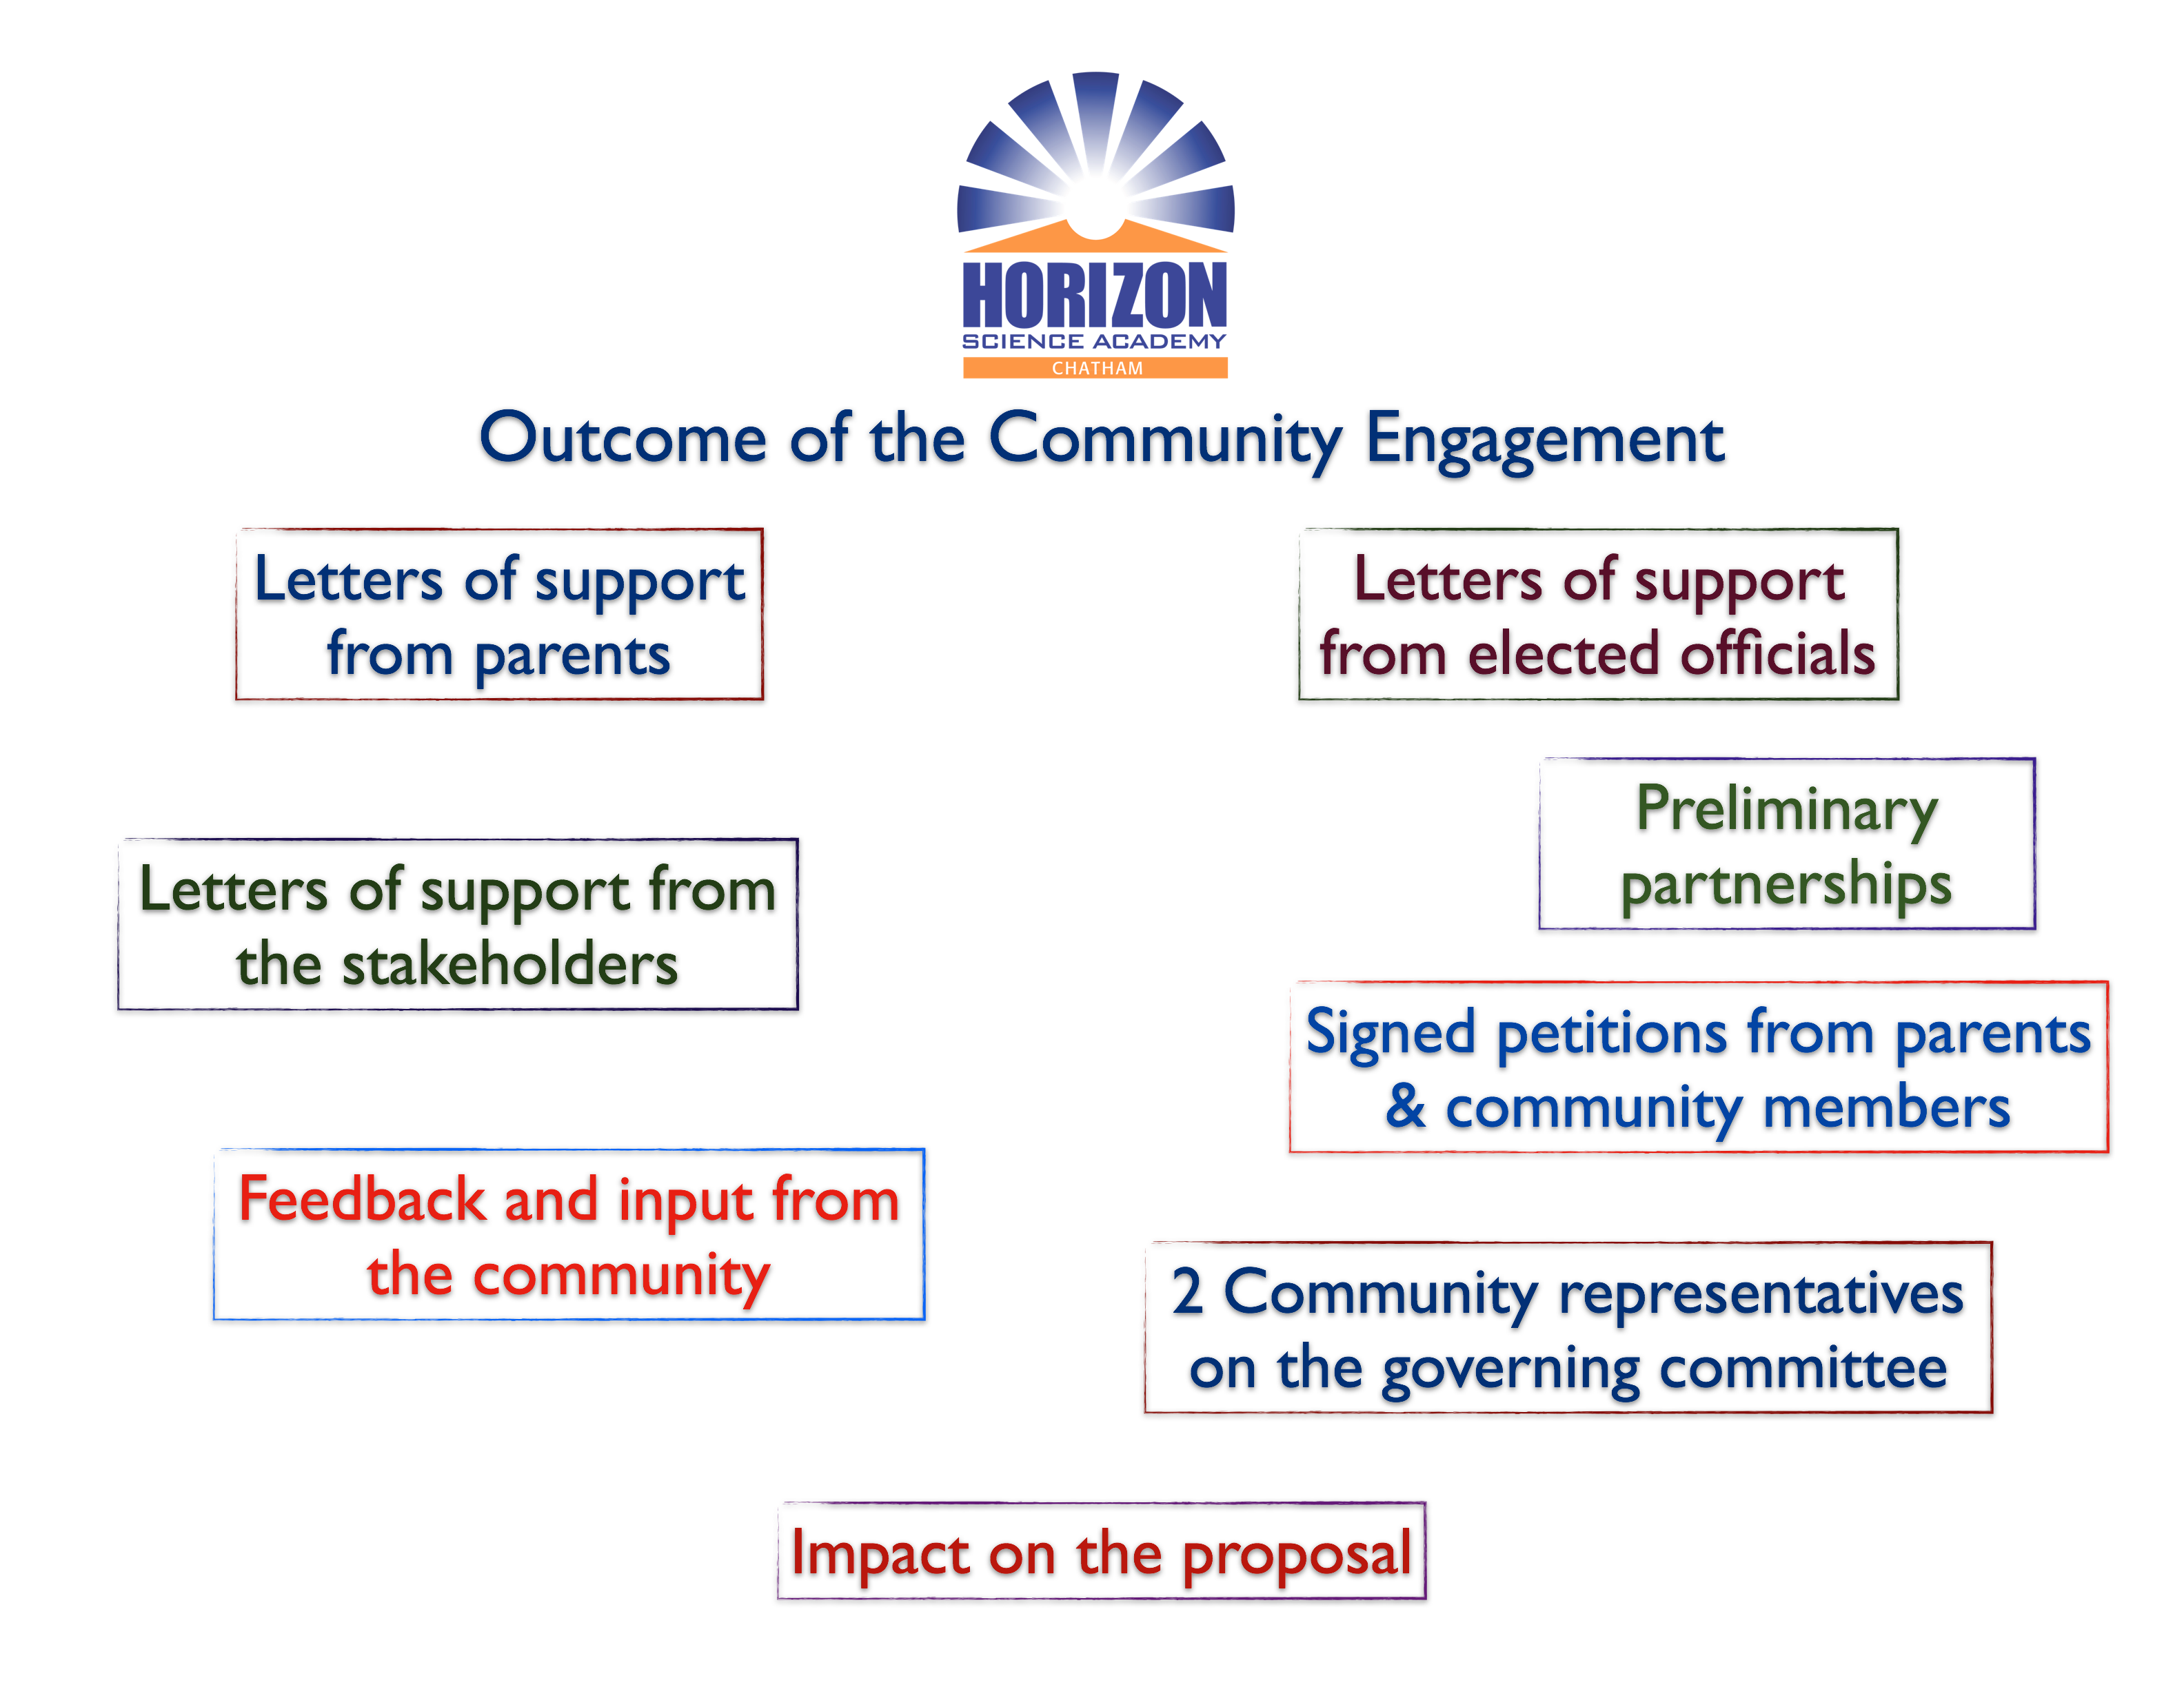
We collected 1477 petitions from parents and community members from the greater Chatham area. Appendix 4-1477 HSA-Chatham Petitions have the electronic copies of those petitions. 95% of the parents who signed the petitions answered the questions of “would you consider sending your child to Horizon Science Academies” as YES.

14 parents who live in the greater Chatham community volunteered to write support letters for the school. These support letters are included in Appendix5-HSA-Chatham Support Letters from Parents. These parents have such compelling, personal stories to share with us in explaining why they support HSA-Chatham in their community.

In addition to the petitions and letters from the parents, we have received support letters from the stakeholders, elected officials, and leaders below:

 | First and Last Name | Title | Organization
1 | Pat Bearden | Executive Director | American Family History Institute
2 | Michael LaFargue | President | West Chesterfield Community Association
3 | Frank Thompson | Commander | The American Legion
4 | Ronald Belamy | Retired CPS Administrator | Marshall and Michelle Clark Schools
5 | Rev. Calvin J. Bridges | President | Chicago Praise Ministries, INC
6 | Betty R. Clawson | Director | Dudley Beauty College, Chicago
7 | Wendell B. O’Neal, Sr. |  | W. B. O’Neal Associates
8 | Clarice E. Mills | President | West Chatham Improvement Association (WCIA)
9 | Gwendolyn Armour | Franchisee Owner | Complete Professional Tax Service
10 | Derryl Shelton | Director of Community Relations & Development | South Central Community Services, INC
11 | Olga Turner | Co-Founder | Fleck's Coffee
12 | Beedie Jones, MEd, NCC | Manager | Mather LifeWays
13 | Ernest Griffin | Manager | Chatham Foods
14 | Andrew Hayes | Vice President | Fifth Third Bank
15 | Howard B. Brookins, Sr. | Senator | Brookins Funeral Home
16 | Melanie David |  | Original Soul Vegetarian
17 | Jack Stonebraker | President | CREED Consulting, LLC
18 | Eli Washington | Chairman | Chesterfield Community Council
19 | Donald Hyun Kiolbassa J.D, CPA | Attorney | Ginsparg, Bolton & Associates, LTD
20 | Howard Brookins | Alderman | 21st Ward
21 | Wynona Redmond | President | Wyn-Wyn Communications
22 | Elgie Sims | IL State Representative | IL
23 | Bobby Rush | US Congressman | IL
24 | Kara Kennedy | Executive Director | Lumity

These letters may be found in Appendix6-HSA-Chatham_Support Letters.

In the Chicago Lawn community, our efforts yielded astoundingly similar support. We collected more than 2,000 petitions from the parents. Again, more than 95% of the parents who signed petitions consider sending their children to HSA-South Chicago. Electronic Copies of the petitions may be found in Appendix7-2031 HSA-South Chicago Petitions.

In addition to the petitions, 34 parents volunteered to share their personal stories as to why they support the creation of HSA-South Chicago in such moving letters. These letters may be found in Appendix8-HSA-South Chicago Parent Support Letters.

The following community stakeholders, leaders of the community based organizations, and elected officials supported the creation of the proposed HSA-South Chicago via letters of support. Such letters of support may be found in Appendix9-HSA-South Chicago Support Letters.

 | First and Last Name | Title | Organization
1 | JoAnn Thompson | Alderman, 16th Ward | City Council, City of Chicago
2 | Antonio Munoz | State Senator, 1st District | Illinois State Senate
3 | Nick Kollias | Commercial Director | Greater Southwest Development Corporation
4 | Jose Alejandro Garcia | Commissioner | Special Service Area 59
5 | Kara Kennedy | Executive Director | Lumity
6 | Daniel Lipinski | US Congressman
7 | Daniel Burke | State Representative | IL
8 | Hector Rico | President | Latino Organization of the Southwest

Outcome of the community engagement efforts in Chicago Lawn is illustrated in the diagram below:
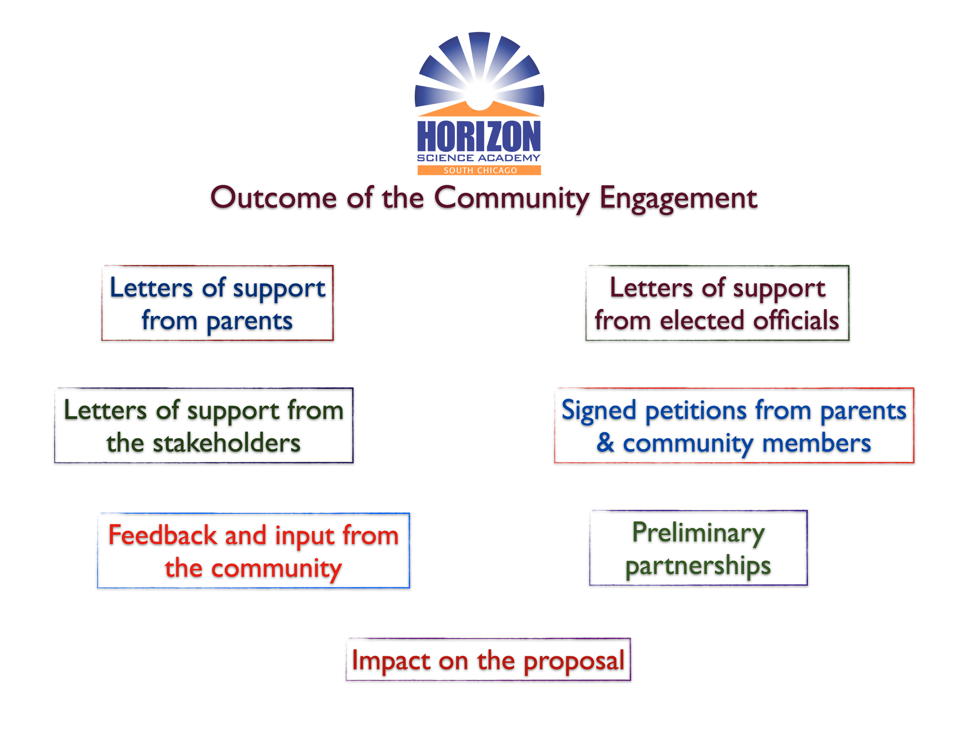
Pictures from our community efforts may be found in Appendix17-Concept Community Engagement Pictures.

  - Section 1.3. Future Plans for Parent and Community Engagement and Partnerships (p. 25)
    - 1.3.a. Key Community Partnerships

We have built a preliminary partnership with Lumity as a result of the community engagement that we have undertaken in Chatham and Chicago Lawn. Lumity is a not for profit that mobilizes the corporate and nonprofit community to make Chicago land a better place to work and live by providing access to real world readiness and connecting nonprofits to vital resources. Impact in the community is delivered through our robust services and programs that include technology consulting, financial support services, training, the MS IT Academy, the STEM collaboration, The Community Corps, and NPO.net, the community’s most active nonprofit job board. Lumity will catalyze Chicago's nonprofit community to do more good work by:

- Increasing the capacity of charitable organizations to more effectively fulfill their missions through technological and financial assistance and solutions
- Providing leadership in digital literacy and education programs to improve the socio-economic conditions of lower-income individuals and families
- Connecting Chicago's corporate, philanthropic, and government leadership to the issues and needs confronting nonprofit organizations
- Defining a brighter future through thought leadership, resources, and education for the broader nonprofit community
Please find a letter of support in Appendix10-Lumity Letter. The partnership will encompass all of the Concept schools in Chicago, not just the proposed ones. We look forward to maturing it in the coming months. As a next step, Lumity team is scheduled to visit Chicago Math and Science Academy on December 11, 2013. More information about Lumity may be found on their website, www.lumity.org

Although it is not solidified yet, we are working on another partnership with South Chicago Development Corp. The management team of the South Chicago Development Corp is scheduled to visit an existing Concept school, HSA-McKinley Park, on December 10, 2013.

    - 1.3.b. School Involvement in Community

Concept Schools’ promise network-wide is organized to enhance and strengthen relationships with parents and connect students with the community around them in order to deliver unique learning opportunities for all students. The momentum that this engagement has brought energizes us. After months of introducing ourselves and hearing directly from parents how excited they are about the proposed school, and how desperately it is needed in the greater Chatham community, we are eager to get to work.

Looking ahead, we expect the momentum to to continue, and for us to continue gathering feedback and ideas on how we can best serve the Greater Chatham community. If given approval to move forward by CPS, we would also transition our outreach efforts to include further engage parents and community partners. In addition to what we had included in the Tier I application, our future activities will include:

- Recruiting residents and/or Chatham business owners to serve on our school board.
- Finalizing partnerships with organizations and entities that expressed interest.
- Seeking out other community organizations and entities that could support the school’s purpose and mission through partnerships and collaborative relationships.
- Joining key community organizations such as the Greater Chatham Business Association and others in order to be in direct contact with the community.

Like in Chatham we expect the same two-way dialogue to continue, and for us to continue gathering feedback and ideas on how we can best serve the parents and families of Chicago Lawn. If given approval to move forward by CPS, we would also transition our outreach efforts to include further engage parents and community partners. Some of our future activities will include:

- Recruiting residents and/or Chicago Lawn business owners to serve on our school board.
- Finalizing partnerships with organizations and entities that expressed interest.
- Seeking out other community organizations and entities that could support the school’s purpose and mission through partnerships and collaborative relationships.
- Joining organization such as the Greater Southwest Development Corporation and others in order be in direct contact with community stakeholders.
- Reaching out to the Arab-American community in a deeper way for a more inclusive dialogue.

  - Section 2.2.a. Roles and Demonstrated Experience (p. 26)
  - Section 2.2.c. School Leadership (p. 28)
  - Section 3.2.c. Board Experience (p. 34)

We have identified the two community representatives who will be the member of the governing committee at HSA-Chatham. Ronald Bellamy and Beedie Jones. Below is the information about both individuals. Their roles on the governing committee of the school have been identified in the Tier II application in the governance section.

Ronald Bellamy has been in the educational field for over 38 years, serving in the following roles

- CPS Physical Education/Classroom Instruction
- Assistant Principal – Marshall High School
- Assistant Principal - Michelle Clark High School
- Ad- Hoc Professor – Chicago State University
- Ad-Hoc Professor – Kennedy King Community College

Mr. Bellamy provided the following services in the aforementioned positions:
- Coaching – football, tennis and swimming
- Transitional Team to turn Michelle Clark School into a High School
- Assistant Principal’s Responsibilities
- Day to Day Operation
- Professional Development
- Strategic Organizational Development
- Managing and Evaluating Staff
- Problem Solving/Trouble Shooting
- Team Management and Building
- Goal Planning
- Conflict Resolution
- Communication Skills
- Security Procedures
- Budgetary planning

Mr. Bellamy is a:
- Former Ad-Hoc Professor at Chicago State University and Kennedy King community College
- Certified Administrator of Type 75
- Honorable Discharged Army Veteran
- Active Member of the Chatham Club Association for over 14 years
- Member of the Harold Washington American Legion

Mr. Bellamy has earned a Bachelor of Science Degree in Education and Master of Science Education Degree from Chicago State University. He received his Education Administrative Type 75 Master of Science degree in Management from Roosevelt University.

Beedie Jones is a graduate of Texas Southern University (B.Sc. in Medical Technology), Pennsylvania State University (M.Ed. in Counselor Education) and completed Advanced Studies in Counselor Education, Student Personnel Administration and a Licensed National Certified Counselor

Beedie Jones is an “aging network” advocate with over 30 years of experience in the field of aging. She has extensive knowledge and expertise in management, training, counseling, project development and community organizing.

Currently, she is the Manager of Mather-More Than a Café located in Chatham and serves on several boards: GRAND Families Program of Chicago, Retired Senior Volunteer Program, the Southside Dementia Coalition and actively participates with the 6th Ward Alderman Office, Chatham Avalon Park Community Council, Member of Chatham Business Association, & supports various senior community events.

Prior to joining the Mather LifeWays Team, she was employed with AARP for 12 years in the AARP Southwest Regional Office, Dallas, Texas, as the Operations for the AARP Southwest Region and State Director for Louisiana and Arkansas. Other professional experiences include: Director of Mature Worker Training & Employment Program, Counselor at Pennsylvania State University, Texas Southern University, University of Texas Medical School and Director of the Histology-Chemical Laboratory at Indiana University Medical School.

We have not identified the community representatives for the governing committee in Chicago Lawn yet. We hope to do so before the end of December.

  - Section 4.1.c. Development Plan (p. 36)

  - Section 4.3. Facilities (pp. 36-37)
    - Section 4.3.a. Facility Plan
    - Section 4.3.b. Space Requirement
    - Section 4.3.c. School Site

As it was mentioned in the Tier 1 application narrative, Concept works with New Plan Learning on facility needs. New Plan Learning ("NPL”) was established in 2005 to provide facilities and support services to new and existing charter schools managed by Concept. While the founders of Concept established NPL, it operates with an independent Board of Directors, management, and employees. New Plan Learning ("NPL") is a nonprofit charter school development corporation that is exempt from federal income tax under Section 501(c)(3) of the federal tax code. Among the services that NPL provides to Concept-managed schools is facility planning, acquisition, renovation, and financing. NPL has successfully completed the following projects to this date from acquisition to occupancy in time within budget. NPL accessed capital markets to finance four projects through tax-exempt bond financing in 2011. The transaction was rated investment grade, BBB-, by Fitch Ratings.
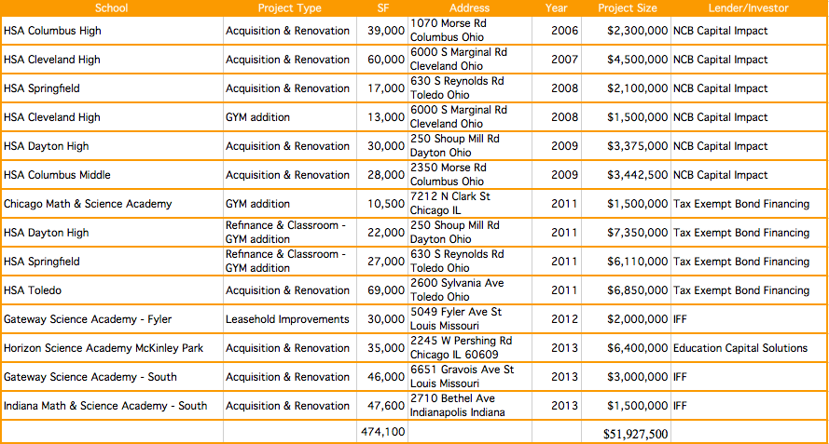
Please refer to Appendix11-New Plan Learning Summary for more information about the organizations and its projects.

Working with NPL, we identified potential facilities for Horizon Science Academy-Chatham and Horizon Science Academy-South Chicago.

For Horizon Science Academy-Chatham, our plan is to lease from Fellowship Education and Economic Development Corp. (FEED). FEED will develop the facility based on our plans and lease it to us. We have agreed on the initial terms and signed a letter of intent, which is attached. Please refer to Appendix12-Signed Letter of Intent for HSA-Chatham. We are currently working on a lease agreement and our plan is to sign the lease agreement before the end of December 2013. Attached (Appendix12-FEED Letter) is a also letter from Fellowship Education and Economic Development Corp. (FEED) confirming their ability to develop the project for us within the appropriate timeline to open our doors to students in the fall of 2014. Appendix13-Concept Facility Related Documents include the followings regarding the proposed facility for HSA-Chatham:

- ADA Compliance Report prepared by Ellen Stoner from Altus Works Architectural Firm
- Inspecting Architect’s Report
- Map that shows the location of the building
- Bird’s eye picture of the facility
- Initial Drawings
- Picture showing the overall the Legacy Project

Concept has partnered with Fellowship Education and Economic Development Corp to be part of a transformational project called the Legacy Project. FEED is a legal affiliate of Fellowship Missionary Baptist Church, charged with education and economic development initiatives. As a Non-profit 501c3 charitable organization, the FEED is the economic development entity overseeing the development of the Legacy Project. The Fellowship Missionary Baptist Church is one of the largest African American churches in the City of Chicago, founded by the legendary reverend and a Civil Right Movement leader, Reverend Clay Evans.

This property is located at 8522 S. Lafayette Chicago, IL 60620. It is and office/warehouse type facility. It is zoned as M2-2 (Light Industry District) by the City of Chicago. The 230,000 sq.ft. closed building sits on a 14.46 acres land. The facility is visible from the west side of the Dan Ryan Expressway traffic count of approximately 262,000 cars/day. The property has been unoccupied since 2004 (9 yrs). The property was historically occupied by a hair care product company including in chronological order:

–Johnson Products Company (first minority firm to be listed on the New York Stock Exchange)
–Soft Sheen
–L’Oreal USA, Inc.

The Green Family that owns Hobby Lobby Stores (Oklahoma City-based national arts and crafts chain) donated the facility to the Fellowship in December 2012. It was a landmark multimillion-dollar donation to Fellowship for approximately ~$9 million. It was the largest donation to an African-American Church in American History.

The Legacy Project is a holistic response to Chicago’s prevailing challenges. The project is an adaptive reuse of the existing land and space.

PHASE I
–Education – Concept Schools
–Health care – Access Health Care
–Daycare – A Child’s Space
–Breakfast style Sit-down Restaurant

PHASE II
–State of the Art Cultural Arts Auditorium
–Youth Conference and Recreational Rooms
–Chapel and Banquet Hall

We updated the lease cost and facility expenses to reflect the agreed terms on the signed letter of intent. Please find the updated financial projections for HSA-Chatham in Appendix14-Updated Financial Projections-HSA-Chatham and for HSA-South Chicago in Appendix15-Updated Financial Projections-HSA-Chatham Changes are highlighted in the “Budget with Assumptions” tab.

For Horizon Science Academy-South Chicago, we identified a potential facility in the Chicago Lawn community. Unlike FEED we plan on purchasing this facility. We have negotiated with the owner and signed a letter of intent. Appendix16-Signed Letter of Intent for HSA-South Chicago has the copy of the signed letter of intent. We are currently working on a purchase agreement and we plan on signing the purchase agreement before the end of December 2013.

Once we sign a purchase agreement, we will begin on zoning changes and other permits as well as securing funding to purchase and build a nice campus for Horizon Science Academy-South Chicago. We do not expect any challenges with the zoning change since Alderman JoAnn Thompson is supportive of the projects and we have a strong community support form the Chicago Lawn community as it was described in details in the precious sections.

We included estimated facility payments lease/mortgage in the multi-year financial projections based on our signed letter of intent and our experience with the investors that we work with. We built two brand new campuses in Chicago within the last five years, CMSA and HSA-McKinley Park. Both were finished on time under budget. Please find the attached Sources and Uses Report for the proposed facility for HSA-South Chicago in Appendix13-Concept Facility Related Documents. In the same appendix you will also find the followings:

- ADA Compliance Report prepared by Ellen Stoner from Altus Works Architectural Firm
- Inspecting Architect’s Report
- Map that shows the location of the building
- Bird’s eye picture of the facility
- 3D Drawings of the project
- Floor Plan
- Signed letter of intent the purchase the facility

For funding, we have had discussions with Entertainment Properties Trust. EPT is interested in funding this project. We are planning to finalize and close our deal with EPR by the end of March 2014. We plan on completing our due diligence on the facility, getting the zoning changed and getting the construction drawings and permits approved by the city until then. Entertainments Properties Trust, EPT, is a specialty real estate investment trust (REIT) that invests in properties in select categories, which require unique industry knowledge, and offer stable returns. EPT has significant financial commitment to public charter schools and is one of the nation’s largest institutional owners of public charter school properties. In just a few years, EPT has invested approximately $235 million in schools educating more than 16,000 students nationwide.

EPT invested an initial $6 M in the facility of McKinley Park this year. Once completed, McKinley Park facility will be a $9 M investment. Please visit following link for further information on Entertainments Properties Trust: www.eprkc.com/Investment-Approach/Public-Charter-Schools

- Please provide updates to any section of the RFP that directly tie to parent or community feedback. For example, if parent or community feedback suggested that the applicant add an after school program, the applicant should provide a response that cites the impact on each relevant section of the proposal, such as:
  - 1.3.a. Key Community Partnerships: In response to suggestions from community members, the Design Team formed a partnership with an existing social service provider in the community. We have attached a Memorandum of Understanding regarding the services that this organization will provide as part of our after school program….
  - 2.1.e. Social, Emotional, and Physical Health: The after school program will provide the following additional social and emotional supports for students….
  - 2.4.d. School Calendar/Schedule: The after school program will take place from 4:30 p.m., after students’ dismissal, until 6:30 p.m.….
  - 2.5.a. Recruitment and Staffing: The after school program will require a Director who will report to the School Executive Director. The change is reflected in the attached school-level organizational chart….

- Please respond to the following three additional questions as a supplement to your original response in Section 2.4.c. Specialized Instruction:
- Please describe how the school will provide a continuum of services for students with disabilities.
The special education department offers a range of services in accordance with student needs. The Response to Intervention process allows general education and special education staff to determine the supports needed to lead to student success. To the greatest extent possible, students will be educated in an inclusive setting with special education supports. The appropriate supports needed are determined through detailed analysis of student strengths and weaknesses. Accommodations, modifications, and instructional goals are tailored to each student’s needs via progress monitoring and differentiation. If students are significantly below grade level, resource or self-contained classes will be considered. Resource classes are incorporated for students who need skill instruction in reading, writing, and/or math to allow them to succeed in inclusion.

Self-contained classes are considered for students who have cognitive impairment or whose instructional levels are significantly below grade level in all areas. The need for self-contained services will be determined through psychological evaluation, as well as collaboration between general and special education teachers. Related services are added for students who require clinical support outside of instructional areas (e.g., behavior, speech). Teachers refer students to clinicians for review and decision of whether related services are required as an IEP team that supports the student and includes the family's participation.

Additionally, to the maximum extent appropriate, students with disabilities will be educated in regular classrooms with non-disabled students. Special classes, separate schooling, or other removal of students with disabilities from the regular educational environment will occur only if the nature or severity of the disability is such that education in regular classes with the use of supplementary aids and services cannot be achieved satisfactorily. Students with disabilities will have an equal opportunity with students in the regular education program to participate in and where appropriate, receive credit for nonacademic, extracurricular and ancillary programs, services, and activities. Students with disabilities will receive the same notices concerning school-sponsored programs, activities and services as other students. Such programs, services and activities include, but are not limited to: art and music, counseling services, health services, transportation, recess and physical education, field trips and other recreational activities, school-sponsored clubs or groups, etc.

- How will you ensure that students are properly placed in the appropriate least restrictive environment (LRE)?

Every student has an individualized education plan which supports each student's education program, by design and service delivery with domains of eligibility being respected. Through Least Restrictive Environment program planning with IEP teams, LRE grids will be monitored to determine program design and needs for IEP students, ranging from inclusive, resource and/ or self-contained settings. Specialized staff would also support those programs, appropriately. For students who might require physical or adaptive supports on site, at the HSA schools would provide those ADA compliant adaptations. For IEP students who may require more restrictive settings, through a partnership between the HSA Special Education Coordinator and the CPS Special Services Administrator, a continuum of services for more restrictive settings, such as a student who needs a different placement for more therapeutic needs, would take place through following those CPS processes and through an IEP team who has collaborated about that placement, along with the family for that student.

- What strategies will you use and what actions will you take prior to changing a student’s LRE?

Through compliant IEP team program reviews with active family participation; reflections of CPS LRE Program Grids; student demographic related reports and/ or an IEP student's case by case need, these components may factor into changes for least restrictive environment settings. Being proactive for our students is essential, as per the Concept Schools philosophy, as we foster student success and respects the importance of transition planning for every student who has a disability. Procedural safeguards are respected throughout this entire process.

2013 New Schools Request for Proposals (RFP)
Tier 2 Questions – Applicant-Specific Questions
- Section 2.2. Design Team Experience and Demonstrated Track Record in Driving Academic Success
  - Please provide additional evidence on the performance of Concept Schools outside of Chicago. Specifically, please explain why nearly half of Concept Schools’ existing schools, most of which have been open for several years, are either under-performing or barely out-performing the local district in math or ELA.

According to performance data given below and in Appendix 1: Concept Network-wide Data provided with our Tier 1 application, 58% of Concept Schools outside of Chicago that had performance data for the 2012-2013 school year significantly out-performed their local school districts. When taking into account the letter grades Concept Schools in Ohio received from the Ohio State Department of Education for their value-added assessment results, 64% of Concept schools are outperforming their counterparts’ district averages in terms of student proficiency rates in reading and math.

Last year, 26 of Concept’s 30 schools had performance data as four of them opened this school year. Of these 26, 25 are outside of Chicago. The below table shows the comparison data between the 14 Concept schools outside of Chicago that significantly out-performed the schools in their districts in math and reading.

CONCEPT SCHOOLS THAT SIGNIFICANTLY OUT-PERFORMED DISTRICTS IN 2012-2013 |  |  |  |  |  |  | PROFICIENCY LEVEL %
 |  |  |  |  |  |  | MATH |  | READING
 |  |  |  |  | 13-14 | 13-14 | 12-13 | 12-13 | 12-13 | 12-13
# | SCHOOL | STATE | OPENED | GRADES | TOTAL | FRL | SCHL | DIST | SCHL | DIST
1 | QUEST PEORIA | IL | 2010 | 5-10 | 448 | 72% | 50% | 40% | 47% | 38%
2 | IMSA NORTH-INDIANA | IN | 2010 | K-10 | 595 | 77% | 77% | 66% | 78% | 59%
3 | MICHIGAN MATH & SCIENCE | MI | 2009 | K-12 | 488 | 68% | 42% | 41% | 83% | 86%
4 | GATEWAY SCIENCE ACADEMY | MO | 2010 | K-10 | 780 | 37% | 56% | 23% | 58% | 25%
5 | HSA- CLEVELAND ELEMENTARY | OH | 2008 | K-5 | 153 | 86% | 49% | 45% | 62% | 55%
6 | HSA- YOUNGSTOWN | OH | 2010 | K-8 | 414 | 98% | 62% | 50% | 71% | 55%
7 | HSA- LORAIN | OH | 2009 | K-10 | 545 | 95% | 66% | 51% | 82% | 64%
8 | NOBLE ACADEMY CLEVELAND | OH | 2006 | K-8 | 351 | 69% | 76% | 54% | 88% | 66%
9 | HSA- SPRINGFIELD | OH | 2005 | K-8 | 440 | 87% | 65% | 54% | 72% | 68%
10 | NOBLE ACADEMY COLUMBUS | OH | 2006 | K-8 | 280 | 70% | 79% | 49% | 78% | 62%
11 | HSA- DAYTON ELEMENTARY | OH | 2005 | K-4 | 164 | 100% | 49% | 40% | 60% | 53%
12 | HSA- CLEVELAND MIDDLE | OH | 2005 | 6-8 | 155 | 79% | 77% | 41% | 87% | 57%
13 | HSA- COLUMBUS HIGH | OH | 1999 | 9-12 | 470 | 70% | 90% | 59% | 90% | 75%
14 | HSA- CLEVELAND HIGH | OH | 1999 | 9-12 | 493 | 83% | 96% | 68% | 94% | 62%

In addition to these significantly high-performing schools within the Concept network, two more Concept schools out-performed their districts in math and reading but not as significantly as the others in the above table. These schools are below:

CONCEPT SCHOOLS THAT OUT-PERFORMED DISTRICTS IN 2012-2013 |  |  |  |  |  |  | PROFICIENCY LEVEL %
 |  |  |  |  |  |  | MATH |  | READING
 |  |  |  |  | 13-14 | 13-14 | 12-13 | 12-13 | 12-13 | 12-13
# | SCHOOL | STATE | OPENED | GRADES | TOTAL | FRL | SCHL | DIST | SCHL | DIST
1 | HSA- DENISON MIDDLE SCHOOL | OH | 2005 | K-8 | 332 | 100% | 58% | 37% | 58% | 56%
2 | HSA- COLUMBUS MIDDLE | OH | 2007 | 6-8 | 465 | 94% | 59% | 50% | 67% | 64%

The two schools above that outperformed their district averages but not as significantly as others did received high letter grades from the Ohio State Department of Education for their value-added assessment results. Below are their value-added grades compared to the districts in which they are located:

SCHOOL INFORMATION |  |  |  |  | Letter Grade of Value-added Assessment by the State
# | SCHOOL | STATE | OPENED | GRADES | SCHOOL | DISTRICT
1 | HSA- DENISON MIDDLE SCHOOL | OH | 2005 | K-8 | C | F
2 | HSA- COLUMBUS MIDDLE | OH | 2007 | 6-8 | A | F

Based on student proficiency rates, there are nine schools within the Concept network that have lower student proficiency rates than the district averages in either reading or math:
CONCEPT SCHOOLS WITH LOWER PROFICIENCY RATES THAN DISTRICTS |  |  |  |  |  |  | PROFICIENCY LEVEL %
 |  |  |  |  |  |  | MATH |  | READING
 |  |  |  |  | 13-14 | 13-14 | 12-13 | 12-13 | 12-13 | 12-13
# | SCHOOL | STATE | OPENED | GRADES | TOTAL | FRL | SCHL | DIST | SCHL | DIST
1 | IMSA WEST-INDIANA | IN | 2007 | K-12 | 589 | 69% | 65% | 66% | 54% | 59%
2 | HSA- TOLEDO DOWNTOWN | OH | 2010 | K-8 | 280 | 92% | 46% | 54% | 60% | 68%
3 | HSA- DENISON ELEMENTARY | OH | 2008 | K-5 | 198 | 89% | 49% | 47% | 58% | 61%
4 | HSA- COLUMBUS ELEMENTARY | OH | 2008 | K-5 | 539 | 75% | 51% | 59% | 67% | 70%
5 | HSA- CINCINNATI | OH | 2005 | K-12 | 491 | 93% | 54% | 69% | 60% | 77%
6 | HSA- DAYTON DOWNTOWN | OH | 2010 | K-8 | 244 | 97% | 38% | 41% | 58% | 55%
7 | HSA- DAYTON HIGH SCHOOL | OH | 2009 | 5-12 | 364 | 64% | 52% | 63% | 63% | 53%
8 | HSA- TOLEDO HIGH SCHOOL | OH | 2004 | K-12 | 565 | 74% | 59% | 63% | 69% | 74%
9 | MILWAUKEE MATH & SCIENCE | WI | 2011 | K-7 | 310 | 94% | 5% | 21% | 2% | 15%

However, when we consider the value-added assessment data for the schools above, six of them show high growth and have received A through C letter grades from their perspective state Departments of Education. Although proficiency rate describes the absolute levels attained by students in their end-of-year tests, value-added assessment data give a powerful diagnostic tool for measuring the effect of pedagogy, curricula, and professional development on academic achievement and provide us a fair and accurate foundation. Below are the value-added data for the six of the nine schools above:
SCHOOL INFORMATION |  |  |  |  | Letter Grade of Value-added assessment by the state
# | SCHOOL | STATE | OPENED | GRADES | SCHOOL | DISTRICT
1 | HSA- TOLEDO DOWNTOWN | OH | 2010 | K-8 | A | F
2 | HSA- DENISON ELEMENTARY | OH | 2008 | K-5 | A | F
3 | HSA- COLUMBUS ELEMENTARY | OH | 2008 | K-5 | A | F
4 | HSA- DAYTON DOWNTOWN | OH | 2010 | K-8 | A | F
5 | HSA- DAYTON HIGH SCHOOL | OH | 2009 | 5-12 | C | F
6 | MILWAUKEE MATH & SCIENCE* | WI | 2011 | K-7 | 67% of the students met their projected growth in NWEA MAP Reading | 62% of the students met their projected growth in NWEA MAP Math
*Milwaukee Math and Science Academy showed 4th-highest growth score (68.6%) out of the seventeen charter schools in the City of Milwaukee.

Within the Concept network, there are only three schools out of 25 outside Chicago with low academic achievement and low-growth, value-added results. These schools are:
SCHOOL INFORMATION |  |  |  |  |  |  | PROFICIENCY LEVEL %
 |  |  |  |  |  |  | MATH |  | READING
 |  |  |  |  | 13-14 | 13-14 | 12-13 | 12-13 | 12-13 | 12-13
# | SCHOOL | STATE | OPENED | GRADES | TOTAL | FRL | SCHL | DIST | SCHL | DIST
1 | IMSA WEST-INDIANA | IN | 2007 | K-12 | 589 | 69% | 65% | 66% | 54% | 59%
2 | HSA- CINCINNATI | OH | 2005 | K-12 | 491 | 93% | 54% | 69% | 60% | 77%
3 | HSA- TOLEDO HIGH SCHOOL | OH | 2004 | K-12 | 565 | 74% | 59% | 63% | 69% | 74%

Opened in 2004, Horizon Science Academy-Toledo High School used to be a high-performing grades 9-12 school until last year. Horizon Science Academy Toledo High Schools used to receive “Excellent” and “Effective” ratings from the Ohio Department of Education for their academic performance.

However, Horizon Science Academy-Toledo High School moved into a new campus and added K-8 grades in the fall of 2012 to become a K-12 school with 517 students. 270 of the 517 students (52%) were the new students in K-8. Therefore, the school struggled in their first year, which led to low student performance and growth. However, with support from Concept management team, the school is doing much netter in its second year at its new campus, and we expect much better results at the end of this school year.

IMSA-West used to be a high-performing school in Indianapolis, too. Due to recent frequent leadership changes, some of which for personal reasons, at IMSA-West, the school’s performance dropped this past year.

Horizon Science Academy-Cincinnati has been a struggling school for the past few years. Although it makes strides towards better academic performance, due to many factors such as leadership changes, high mobility rate, and a challenging facility, the school’s performance was not at the level that we wanted.

Working with the local school board and administrative teams, Concept Schools has developed improvement plans for not only for the aforementioned three schools but also for all of the nine schools with low proficiency rates regardless of their growth data. The improvement plans include strategies in the following categories:
- Instruction
- School culture
- Technology
- Staff development
- Remediation and intervention
- Parental involvement

In order to provide these schools with more support, Concept Schools created new regions in Indiana and Dayton/Cincinnati, Ohio. Each new region includes a superintendent, an instructional coach, a community outreach coordinator, and finance staff. With the new smaller regions, we are able to not only provide better-quality support to the schools, but also we are able to monitor the implementation of the Concept design at the schools, which ensures high academic performance and success.

Along with the new improvement plans that we have developed, we are allocating more resources and support to the aforementioned schools. We believe the results will change as early as this year at these schools and no low-performing schools will exist in the Concept network as soon as next year.

- In regard to Sections 2.1. Mission, Vision, and Culture; 2.3. Educational Goals and Assessment Plan, and 2.4. Curriculum and Instruction
  - Please provide more information on how specific practices, strategies, policies, supports and/or norms that have helped drive student achievement at Chicago Math and Science Academy may be extended to the elementary school level.

Chicago Math and Science Academy is one of the 30 schools within the Concept network, implementing the Concept Schools’ educational design. Concept’s educational design is a student-centered and evidence-based model that has proven successful at many schools and communities similar to Chatham and Chicago Lawn. However, although the overall Concept design is evidence-based, it includes many research-based components, too. Our Tier I application had references to the particular research studies that supported various features of the Concept design.

The proposed schools, HSA-Chatham and HSA-South Chicago, will be implementing the Concept design to its fullest extent. What we propose is not replication of CMSA, but rather replication of the Concept design, which is explained in detail throughout the Tier I application. Therefore the proposed schools will share similar characteristics to those of CMSA due to the fact that they will be implementing the same model.

Chicago Math and Science Academy is successful because there is high fidelity to the Concept design. Chicago Math and Science Academy is one of the flagship schools within the Concept network. However, the Concept network includes schools such as Horizon Science Academy-Cleveland, Horizon Science Academy-Columbus, and Noble Academy-Cleveland that are even more successful than CMSA. Within the network, there is a strong correlation between the levels of fidelity a school has and the level of success attained. Some of the flagship schools within the Concept network are elementary schools.

The Concept Schools design is a comprehensive school design comprising many components. It is like a fine Swiss watch. On the outside it may seem to work effortlessly, but once the face is removed, many gears, levers, springs, and dials work harmoniously to achieve the desired outcome, which is accurate timing. With all its components, the Concept design works harmoniously to achieve the desired outcome, which is the student achievement. The major components of the Concept design are as follows:

- Rigorous college preparatory curriculum with a math, science, and technology emphasis
- Longer school days and extended school year
- Small school (735 students in K-12) and class sizes (maximum 25 students in a class)
- Personalized education
- Data-driven instruction through ongoing assessment of learning
- College exposure beginning in early grades
- Project- and application-based programs such as PLTW
- Technology integration in the curriculum
- A comprehensive academic support system for all students (acceleration and intervention)
- Higher standards and expectations for all students
- Knowledgeable, dedicated, and skilled staff
- Increased student engagement beyond classroom
- A motivating, positive, and success-oriented culture
- Student advisory system
- Increased parental involvement
- Sustainable, and service-oriented relationships with students and parents
- Productive community partnerships

The effectiveness of the Concept Design has been identified by CREDO in a recent research study. The Center for Research on Education Outcomes (CREDO) at Stanford University released an extensive research study on January 30, 2013, on the performance of charter school operators. The Stanford researchers followed student-level performance in schools for five years, mapping charter schools’ academic showing against a “static set of performance thresholds” so that academic trends over time could be evaluated. The analysis of charter management organizations is based on a “virtual control record” method, in which students in those schools are compared to "virtual twins" who attend regular public schools the charter school students would otherwise have attended.

One hundred sixty-seven Charter Management Organizations and 1,372 of their schools are included in the study. In addition to the CMOs, 38 different EMOs and their 410 schools were examined.

Concept is an education management organization. It provides management services to its schools based on an annual agreement with local charter boards, which hold the charter. The CREDO study finds EMOs outperforming the CMOs and others. “EMOs are the surprise in this analysis—and while the individual EMO results show variation just like the CMOs, they appear to outperform the CMOs, the direct-run independent charters and the TPS local markets in a consistent fashion.”

Concept Schools stands out further in the CREDO study. Concept is one of the highest-performing EMOs in the 25 states that the CREDO study covered.
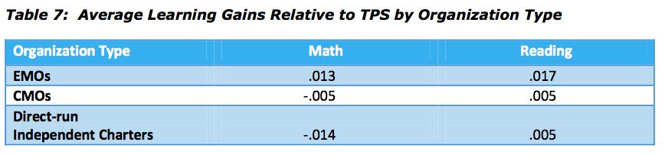
Concept Schools | .06 | .04

Growth Effect Size is the average change in performance of students attending a network school compared to Virtual Control Record. The effect sizes are measured in standard deviations. This means that they are comparable across states and network types. Essentially, the higher the growth effect size, the more students in that network improved during the years that the study covered.

As seen in the table above, the growth effect size of Concept is significantly higher than averages of EMOs, CMOs, and direct-run independent charter schools.

On the next page the growth effect sizes of EMOs in math and reading are listed. Concept may easily be considered as the highest-performing EMO on the list when the poverty level, percentage of minority students, and number of students are taken into consideration.
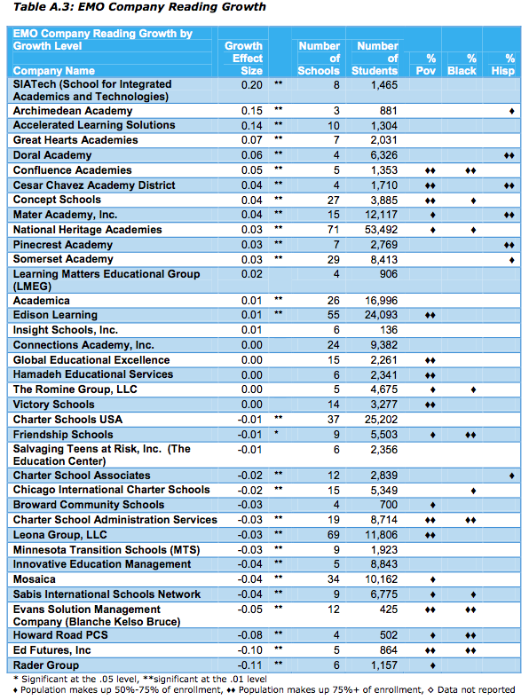

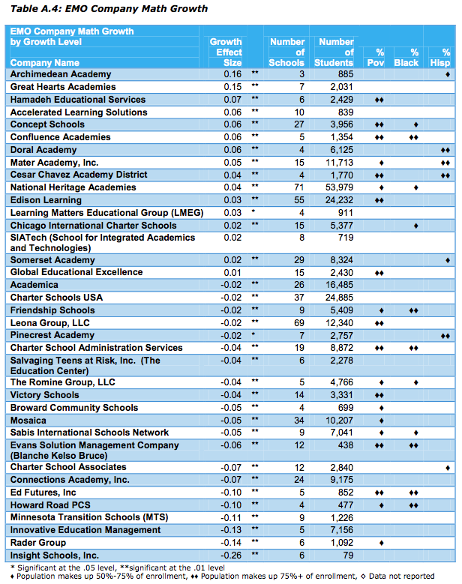

Full report may be found on the CREDO web site, www.http://credo.stanford.edu

In terms of the particular instructional strategies that the proposed Horizon Science Academies will implement, they are explained in details in the curriculum and instruction section, section 2.4, of the Tier I application. All of these instructional strategies are implemented at CMSA, too and they contribute to the success of the school significantly.

