**UNIT 7 TEST: Systems of Equations** Name ____________________

**Part 1: MULTIPLE-CHOICE**

Answer all of the following to the best of your ability. SHOW ALL WORK in the space provided. Circle your final answer and fill-in your answer choice on your scantron.

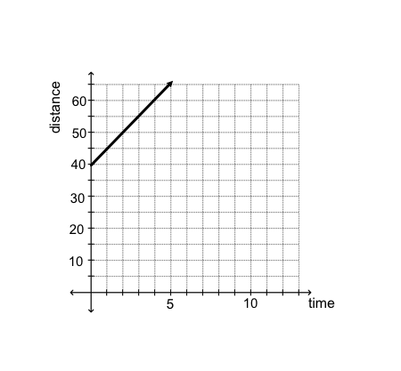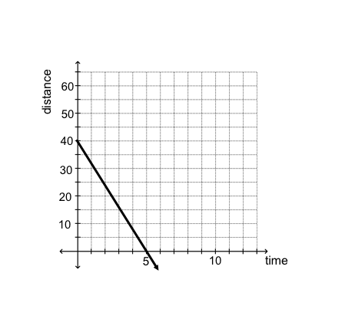**1.** Martin starts 40 feet away from a motion detector and begins walking away from the detector at a pace of 5 feet per second. Which graph represents his position over time?

A. B.

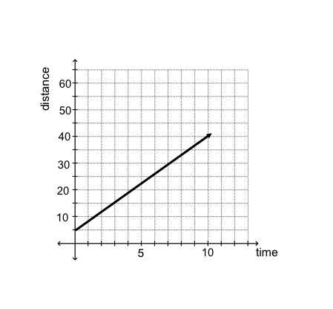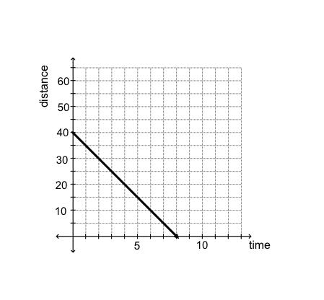

C. D.

**2.** What is the sum of 4.742 and 3.130 when rounded to the nearest hundredth?

A. 7.9 B. 7.87 C. 7.872 D. 8.0

**3.** When their car breaks down, and husband and wife decide to split the cost of the bill. The bill including tax, but not labor charges, was $560. The husband pays for 40% of the bill while the wife pays for 60%. The labor charge adds 15% to each of their shares of the bill. What is the total amount that the wife paid for the car repairs?

A. $420.00 B. $351.00 C. $386.40 D. $257.60

**4.** What is the slope of the line that goes through the points (4, 9) and (-3, 9)?

A. m = 0 B. undefined C. x = 0 D. y = 9

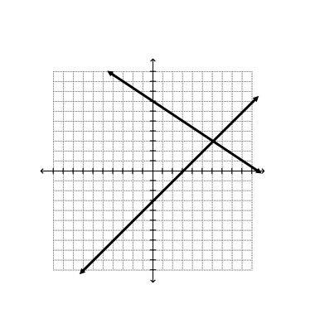**5.** Below is the graph of the system . Which of the following is the solution to the system?

A. No Solution

B. Infinitely Many Solutions

C. (6, 3)

D. (3, 0)

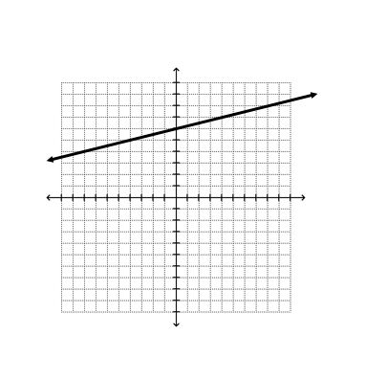

**6.** Which of the following equations represents the line graphed in the standard (x, y) coordinate plane shown below?

A. y = x + 6

B. y = -4x + 6

C. y = x + 6

D. y = 4x + 6

**7.** If x = y + 2 and 5x = 2y + 15, then what is the value of y?

A.  B.  C.  D. 

**8.** What is the x-coordinate of the following system?



A. -8 B. -6 C. -2 D. No solution

**9.** Which of the following could be added to 15.13 so the sum has does not have an 8 in the hundredths place?

A. 1.25 B. 1.15 C. 0.05 D. 0.17

**10.** Which of the following expresses all possible solutions for the inequality?

8x + 9 > 15 + 4(2x – 1)

A. x > 9 B. x < 11 C. No Solution D. All Real Numbers

**11.** On a standard (x, y) coordinate plane, a line with equation y = bx + c is less steep than a line with equation y = 3x + 4. Which of the following must be true?

A. b < 3 B. b > 3 C. -3 < b < 3 D. None of These

**12.** What is the value of x in the solution to the system of equations below?

4x + 3y = 9

8x + 5y = 11

A. -3 B. 3 C. 7 D. -7

**13.** A system that has infinite solutions consists of what kind of lines?

A. The same line B. Parallel Lines

C. All of the above D. None of the above

**14.** How many centimeters are in a meter?

A. 1 B. 10 C. 100 D. 1,000

**15.** Solve the given system. 

A. No Solution B. (0, 0)

C. Infinitely Many D. 

Solutions

**16.** What is the solution to the following system?



A. (-3, 10) B. (4, -1) C. (-1, 4) D. Mr. Panther ☹

**17.** If 3g – 2h = 4 – h, what is the value of h when g = -7?

A. -25 B. 25 C. 17 D. -17

**18.** What is the slope of a vertical line?

A. undefined B. 0 C. positive D. negative

**19.** Is (4, 1) a solution to the following system?

5x – 2y = 18

x – y = 5

A. Yes B. NO

**20.** At the grocery store your bill totals $23.76. The store charges a 6.5% tax, but you have a 10% off coupon. How much will you pay with tax and the coupon? Round to the nearest cent.

A. $24.59 B. $27.68 C. $22.77 D. $25.83

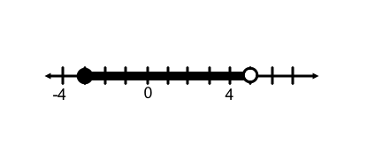

**21.** Which of the following compound inequalities represents the solution set graphed below:

A. x ≥ -3 or x < 5 B. x > -3 or x ≤ 5

C. x ≥ -3 and x < 5 D. x > -3 and x ≤ 5

**22.** Which of the following systems has no solution?

A.  B.  C.  D. 

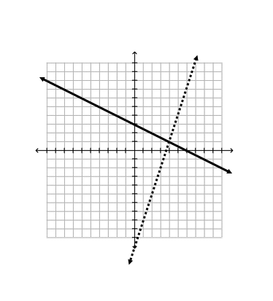

**23.** What is the solution to the following system?

A. (4, 1)

B. (6, 0)

C. (7, 5)

D. (15, -1)

**24.** Which of the following best describes the solution to a system of equations?

1. A number on a line.
2. The point where two lines intersect.
3. Every point on the coordinate plane.
4. The best point in the world.

**25.** What is the y-value of the solution to the following system?



A. (-4, 3) B. 3 C. -4 D. (3, -4)

NAME___________________________

**FREE RESPONSE**

Solve the systems below using the given method. SHOW ALL WORK. Write your answer in the space provided. (3 points each)

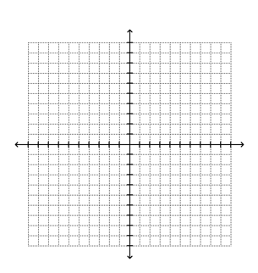

**1.** Solve the given system by **graphing** in the provided coordinate plane.



**#1 ANSWER:**

**2.** Solve the given system by **substitution**.



**#2 ANSWER:**

**3.** Solve the given system by **elimination**.



**#3 ANSWER:**